**PRIMARY SIX THIRD TERM MTC SCHEME OF WORK**

|  |  |  |  |  |  |  |  |  |  |  |  |  |  |
| --- | --- | --- | --- | --- | --- | --- | --- | --- | --- | --- | --- | --- | --- |
| **W**  **K** | **P**  **D** | **THE ME** | **TOP**  **IC** | **SUB TOPIC** | **CONTENT** | **COMPETENCES** | | **IND. OF**  **LIFESKILL**  **S &**  **VALUES** | **MTHDS/**  **TECHNI**  **QUES** | **ACTIVIT**  **Y** | **IMS** | **REF** | **R**  **E**  **M** |
| **1** | **1**  **&**  **2** | **ME**  **AS**  **UR**  **ES** | LENGTH  MASS  AND  CAPA  CITY | **Length** | ***Conversion of units.***  ***Converting kilometers to metres***  ***And vice versa***  ***Example***  Change 3km to metres.  1km = 1000m  3km = 3x1000m  = 3000m | **LANGUAGE** | **SUBJECT** | Observati on  Appreciat ion  Accuracy | Explanat  ion  Demons  tration | Estimati ng  Measuri ng  Recordi ng | Real object s  Real object s  Chalk board illustra tions | Mk maths book 6 page 313-314  P.6 curriculum page 175 and 176 |  |
| The learner; - describes the term length - reads statements correctly. | The learner; - measures the lengths of different objects. - records length of different objects. - relates units - converts kilometers to metres & viceversa |
|  | **3** |  |  |  | ***Expressing centimeters to metres and vice versa.***  ***Examples***  ***Express the following as centimetres***  EXAMPLES   1. 2m 2. 35m 3. 0.34m   10 = 4.8m | The learner; - reads statements correctly. | The learner;  - relates units - converts metres to centimetres. - converts centimetres to metres. | Interpreta tion  Problem solving  Critical thinking | Illustrati on | Converti ng units from one unit  to another | A chart showi ng metric units.  Chalk board  illustra tion | Mk maths book 6 page  315-316 P.6 curriculum page 175 and 176 |  |

|  |  |  |  |  |  |  |  |  |  |  |  |  |  |
| --- | --- | --- | --- | --- | --- | --- | --- | --- | --- | --- | --- | --- | --- |
| **WK** | **PD** | **THEME** | **TOPIC** | **SUB TOPIC** | **CONTENT** | **LANGUAGE** | **SUBJECT** | **METHODS** | **LIFE SKILLS** | **ACTIVITY** | **IMS** | **REF** |  |
|  | 4 |  |  | **Circle** | **Parts of a circle**   * relating diameter and radius. * diameter is twice the radius.   Example  1. Find the radius of a circle whose diameter is 14cm.  R = D  2  = 14cm  2 = 7cm  2. Calculate the diameter of a circle whose radius is 3 ½ cm. D = 2r  = 2xr  = 2x3 ½ cm  = 2 x 7  2 = 7cm | The learner; - describes a circle  - reads and spells new terms. | The learner;   * names the   parts of a circle. - relates diameter and radius   * finds diameter and radius | Logical thinking  Critical thinking  Interpreta tion  Problem solving | Demons  tration  Observa  tion  Explanat  ion  Discussi on | Naming  parts of a circle  Finding radius and diameter | A chart showi ng parts of a circle  Findin g radius and  diamet  er | Mk maths book 6 page  327 P.6 curriculum page 175 and 176 |  |
|  | 5 |  |  |  | Finding pie (𝜋) using diameter and circumference. - get a circular object and measure its circumference - measure its diameter - divide circumference by diameter to get pie (𝜋)  𝜋 = C  D  C = 𝜋 D | The learner; - reads statements correctly. | The learner; - describes diameter and circumference - identifies the symbol for pie  ( )  - finds pie using diameter and circumference | Accuracy  Problem solving | Demons tration  Observa  tion | Finding pie | Circul ar object s  Chalk board illustra tion | Mk primary maths book 6 2000 page  326 P.6 curriculum page 175 and 176 |  |
|  | 6 |  |  |  | ***Calculating circumference of a circle.*** Formula used: C = 𝜋D or  2 𝜋 r  ***Examples***  Find the circumference of a circle whose: 1) radius is 7cm  C = 2 𝜋r  = 2 x x7  = 2 x 22 = 44cm | The learner; - reads and interprets  statements correctly. | The learner; - finds circumference  when given diameter. - finds circumference when given the radius. | Interpreta tion  Critical thinking  Observati on | Explanat ion  Guided discover y  Illustrati on | Finding circumfe rence | Chalk board illustra tion | Mk maths book 6 page 328  P.6 curriculum page 175 and 176 |  |

|  |  |  |  |  |  |  |  |  |  |  |  |  |  |
| --- | --- | --- | --- | --- | --- | --- | --- | --- | --- | --- | --- | --- | --- |
|  |  |  |  |  |  |  |  |  |  |  |  |  |  |
|  | 7 |  |  | **Area of shape** | ***Square:***  - A square is a quadrilateral with all its sides and angles equal.  **Example**  Find the area of a square whose side is 6cm.  A = 5x5  = 6cm x 6cm  = 36cm2  Finding one side of the square.  **Example**  The area of a square is 16cm2. Find the length of each side of the square.   |  |  | | --- | --- | | 2 | 16 | | 2 | 8 | | 2 | 4 | | 2 | 2 | |  | 1 |   A = S+S  pcmxpcm=16cm2 | The learner; - describes a square  - spells the term square - reads and interprets statements. | The learner; - draws a square and shows all the properties - finds the area of a square. - finds the side of a square when given area. | Logical thinking  Interpreta tion  Critical thinking | Explanat  ion  Guided discussi on | Finding area of a square | Chalk board illustra tion | Mk maths book 6 page  329 P.6 curriculum page 175 and 176 |  |
|  |  |  |  | **Area of shapes** |  |  | Accuracy  Problem solving | Questio n and answer | Finding the length of a square when given area | Chalk board illustra tion | Mk maths book 6 page  330 P.6 curriculum page 175 and 176 |  |

|  |  |  |  |  |  |  |  |  |  |  |  |  |  |
| --- | --- | --- | --- | --- | --- | --- | --- | --- | --- | --- | --- | --- | --- |
| 2 | 1 |  |  |  |  | The learner; - reads and  spells the term rectangle. - describes a rectangle. - names the  sides of a rectangle. - reads and interprets statements. | The learner; - identifies equal sides of a rectangle. - finds the area of a rectangle. - finds the side of a rectangle when given area. | Interpreta tion  Critical thinking  Problem solving | Explanat  ion  Discussi on | Finding the area of a rectangl e | Chalk board illustra tion | Mk maths book 6 page  331 P.6 curriculum page 175 and 176 |  |
|  |  |  |  |  | Finding the side of a rectangle when given area.  ***Example***  The area of a rectangle is 56cm2. Find the width if its length is 8cm   |  | | --- | | 56cm2 w |   8cm  A = L x w  8cm x w = 56cm2  8w = 56  8w = 56  8 8  w = 7cm |  |  | Logical thinking | Questio n and area | Finding missing side of a rectangl e | Chalk board illustra tion | Mk maths book 6 page  332 P.6 curriculum page 175 and 176 |  |

|  |  |  |  |  |  |  |  |  |  |  |  |  |  |
| --- | --- | --- | --- | --- | --- | --- | --- | --- | --- | --- | --- | --- | --- |
|  | 2 |  |  | **Perime**  **ter of**  **shapes** | Perimeter of a square.  Perimeter: Is the total distance around the figure.  ***Example***  Find the perimeter of the figure below.  5cm  P = add all sides  = S+S+S+S  = 5cm +5cm+5cm+5cm  = 10cm +10cm  = 20cm | The learner; - describes the term perimeter. - reads and interprets statements. | The learner; - finds the perimeter of a square.  - finds the length of a square when given perimeter. | Logical thinking  Problem solving | Explanat  ion  Discussi on  Questio n and answer | Finding a  perimete  r of a square | Chalk board illustra tion | Mk maths book 5 page  157-158 P.6 curriculum page 175 and 176 |  |
|  |  |  |  |  | Finding the side of a square when given perimeter.  **Example**  The perimeter of a square is  40m. Find the length of the side. S  S  S  S  P = add all sides  S+S+S+S = P  S+S+S+S = 40m  4S = 40  4S = 40  4 4  S = 10m |  |  | Logical thinking  Interpreta tion | Explanat  ion  Discussi on | Finding missing  side of a square when given perimete  r | Chalk board illustra tion | Mk maths book page  157-158 P.6 curriculum page 175 and 176 |  |
|  | 3 |  |  |  | ***Rectangle:***  Finding the missing side of a rectangle when given perimeter. ***Example*** | The learner; - reads and interprets statements | The learner; - finds the perimeter of a rectangle. - finds the missing side of a | Critical thinking  Problem solving | Questio n and answer | Finding the missing side of a rectangl e | Chalk board illustra tions | Mk maths book 6 page  333 P.6 curriculum |  |

***Rectangle***: is a quadrilateral with two opposite sides equal. Has all sides equal

|  |
| --- |
| c |

a

b

a = c b = d

***example***

find the area of the rectangle below

12cm

5

c

m

A = Lx w

= 12cm x 5cm

= 60cm2

The perimeter of a rectangle is

24

cm. Find its length if the width

is 5cm

5

c

m

L

P = add all sides

l+w+l+w = P

l+5+l+5 = 24cm

l+l+5+5 = 24

24

l +10 =

2

2

l +

10

-

=

10

24

-

10

2

l

= 14

2

l

=

14

2

2

L = 7cm

rectangle when

given perimeter.

Interpreta

tion

page 175

and 176

4

**Perime**

**ter and**

**area of**

**a**

**rectan**

**gle**

Finding sides, area and

perimeter.

***Example***

ABCD is a rectangle

1)

A (2x

-

5)

cm B

x

(

-

1)

cm

D (x+3)cm C

a) Find the value of x.

(2

x

-

5)

=

(x+3)

2

x

-

5

= x

+3

2

x

-

+3+5

x

5+5 =

2

x = x

+8

2

x

–

x = x

-

x+8

x = 8

The learner;

-

identifies

equal sides of

a rectangle.

The learner;

-

finds the

unknown by

comparing sides.

-

finds the actual

length and width.

-

finds the area

and perimeter of

the rectangle.

Accuracy

Problem

solving

question

and

answer

Finding

the

unknow

n actual

length

and

width

Area

Perimet

er

chalkb

oard

illustra

tions

mk maths

book 6 page

334

-

335

P.6

curriculum

page 175

and 176

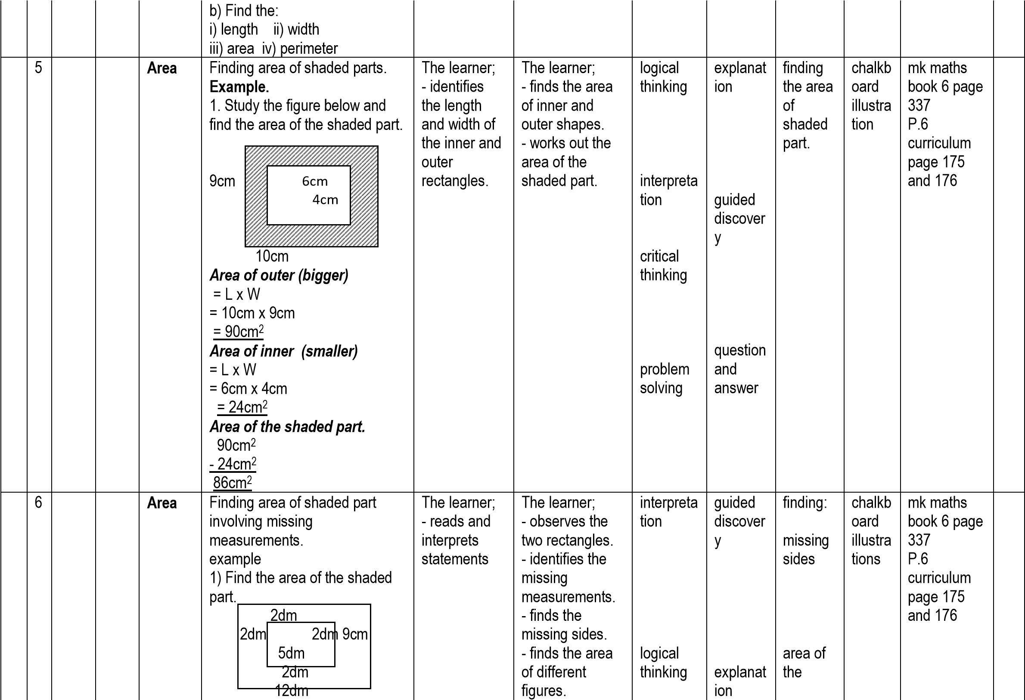

First find missing sides

Length of the outer rectangle.

8dm+2dm

=

+

dm

2

=

12dm

width of the outer rectangle.

5dm+2dm+2dm

=

=

9dm

area of the outer rectangle.

=

LxW

12dmx9dm

=

=

108dm

2

Area of inner rectangle.

L x W

=

8dm x 5dm

=

40dm

=

2

Area of the shaded part.

=

108dm

2

-

40

dm

2

dm

68

2

observati

on

problem

solving

illustrati

on

question

and

answer

shaded

parts

7

Finding area of a triangle.

**Example.**

Find the area of the triangle

below.

m

5

m

7

6

m

m

13

formula used:

A = ½ x bxh

=

½ x13mx6m

=

1x13mx3m

39m

=

2

2)

The learner;

-

identifies

the base and

height.

-

reads and

interprets

statements

correctly.

The learner;

-

finds the area

of given

triangles.

logical

thinking

interpreta

tion

observati

on

explanat

ion

guided

discussi

on

finding

area of

triangles

chalkb

oard

illustra

tions

mk maths

book 6 page

338

P.6

curriculum

page 175

and 176

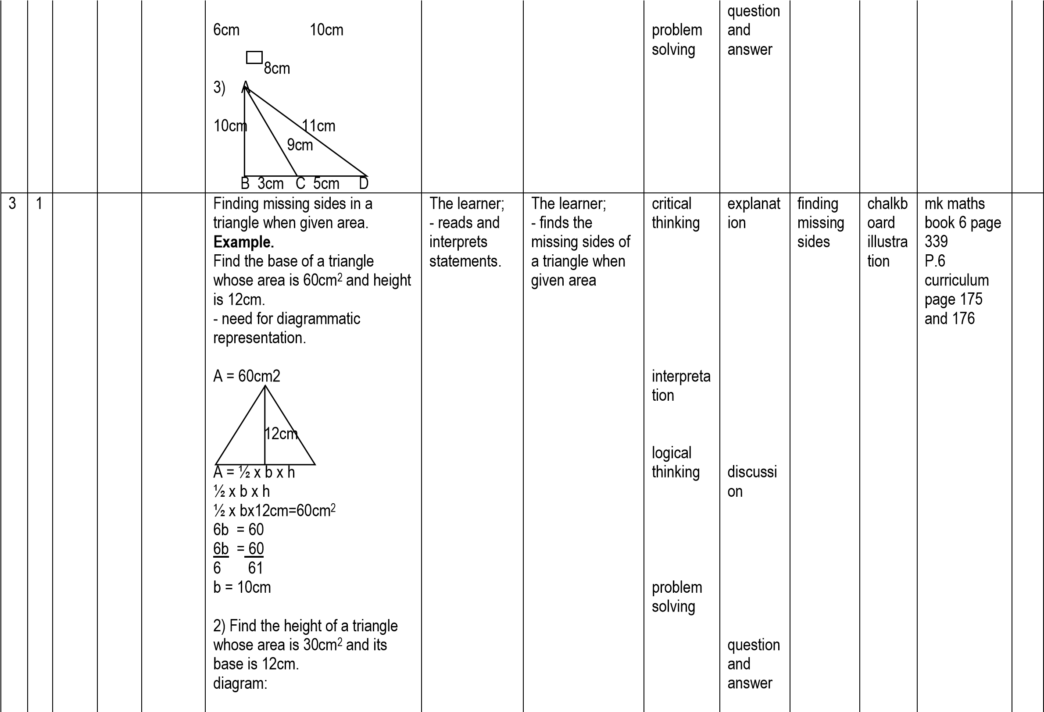

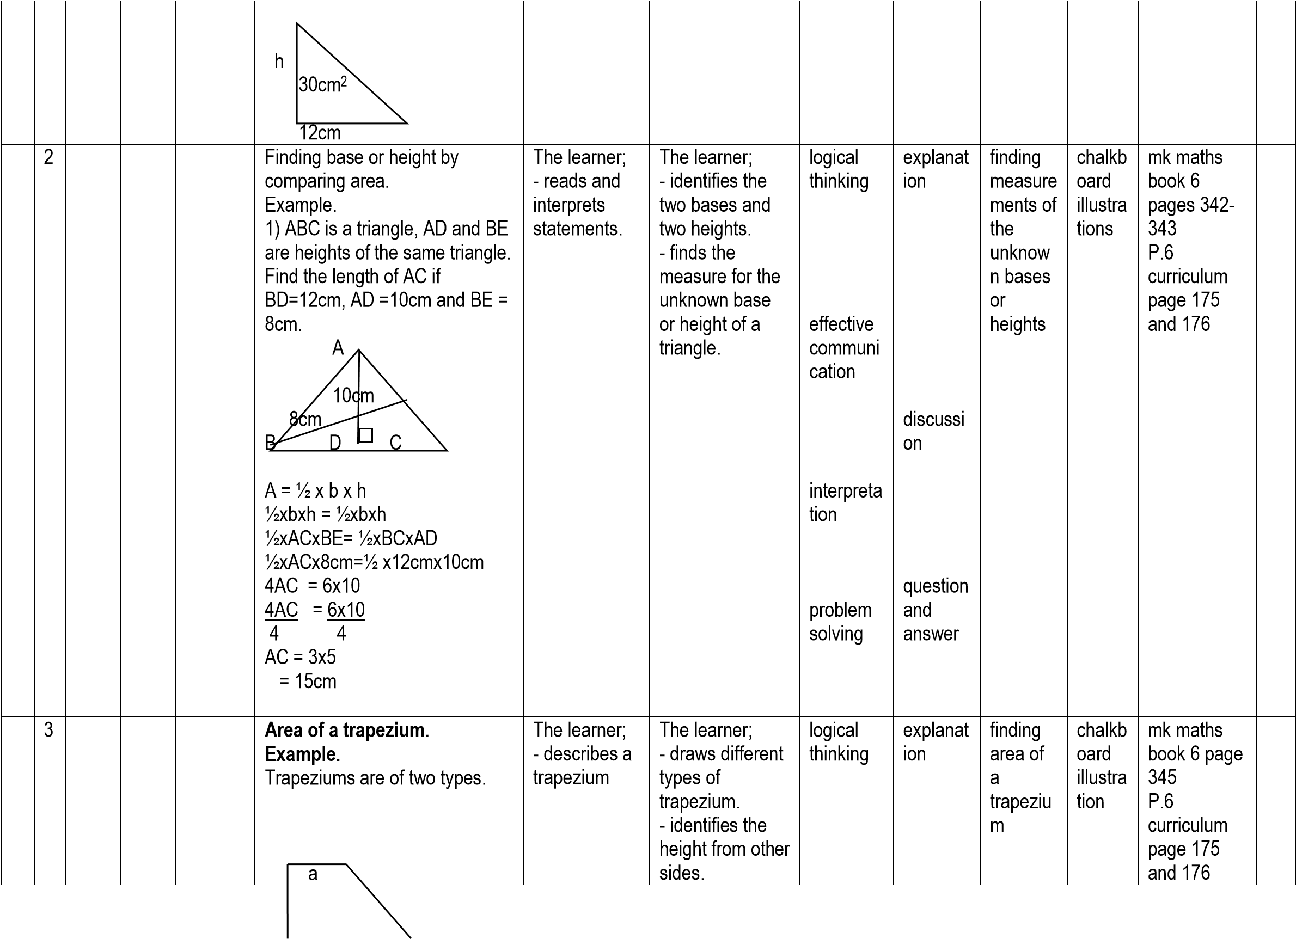

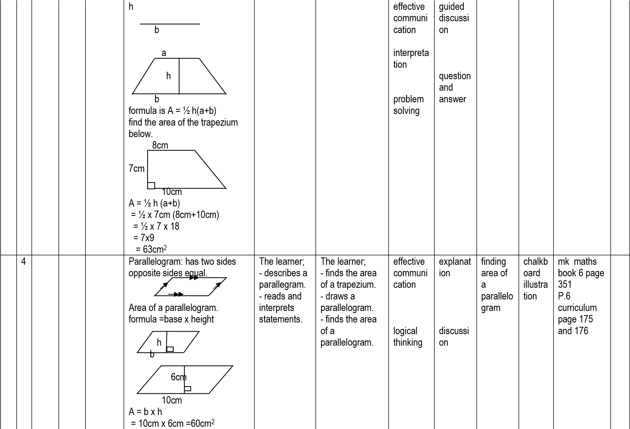

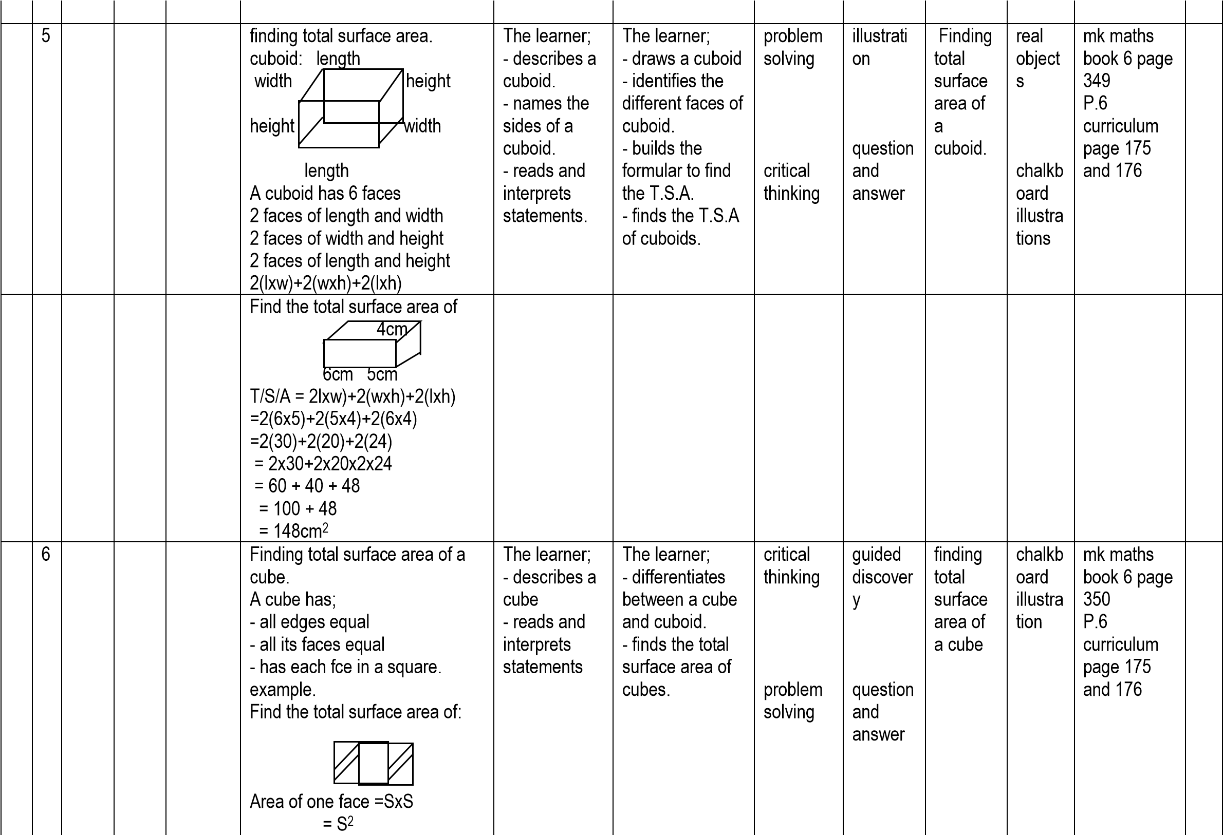

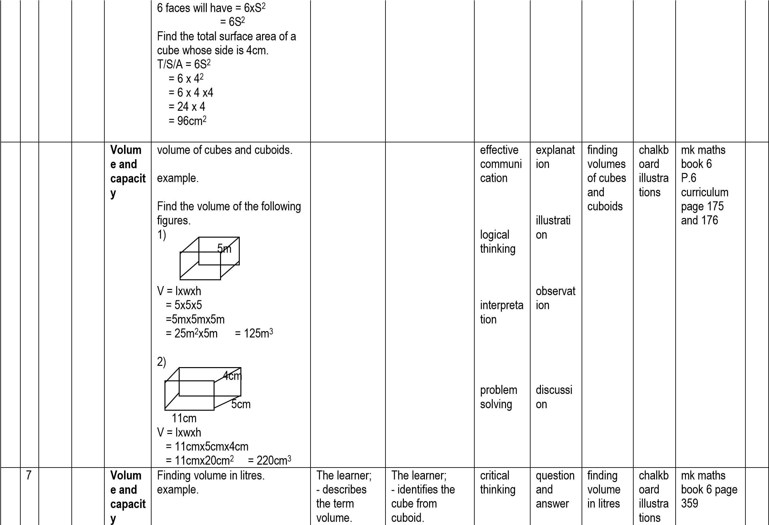

A rectangular tank is 30cm by

cm by 90cm. Find its volume

60

in litres.

Sketch

90

cm

60

cm 30cm

1

l = 1000cm

3

/cc

V=lxwxh

=

cmx60cmx90cm

30

1000

cc

=

30

cmx6cmx90cm

cmxcmx9cm

1000

=

9

3 x 6 x

9

18 x

=

162 litres

=

-

relates litres

and cubic

centimetres.

-

reads and

interprets

statements.

-

identifies units

used for volume.

-

finds the

volume of given

figures.

-

finds volume in

litres

effective

communi

cation

explanat

ion

discussi

on

P.6

curriculum

page 175

and 176

4

1

finding missing sides.

examples.

The rectangular prism

1)

below

has a volume of 180cm

3

.

Find its height.

h

4

cm

9

cm

V=lxwxh

x4xh = 180c.c

9

= 180

h

36

= 180

h

36

36

36

h = 5cm

72

The rectangular tank holds

2)

litres of water. Find its width.

15

cm

The learner;

-

reads and

interprets

statements

correctly.

The learner;

-

forms

equations.

-

solves for the

unknown.

problem

solving

critical

thinking

question

and

answer

chalkb

oard

illustra

tions

mk maths

book 6 page

359

P.6

curriculum

page 175

and 176

|  |  |  |  |  |  |  |  |  |  |  |  |  |  |
| --- | --- | --- | --- | --- | --- | --- | --- | --- | --- | --- | --- | --- | --- |
|  |  |  |  |  | 80cm |  |  |  |  |  |  |  |  |
|  | 2 |  |  | **Weight /mass** | Conversion of units examples.   1. Change 9kg to grams.   1kg = 1000gms  9kg = 9x1000gms  = 9000gms   1. Express 480gms as kg   1000gm = 1kg  1 gm = 1 kg  1000  480gms = 1 x 480kg    =  100  = 0.48kg | The learner; - describes the term weight. - reads units used in weight. | The learner; - converts kg to grams. - convert grams to kg. | interpreta tion  effective communi  cation | explanat  ion  guided discussi on | converti ng of units | chalkb oard  illustra tions | mk maths book 6 page  366 P.6 curriculum page 175 and 176 |  |
|  | 3 |  |  |  | Addition and subtraction of kilograms and grams.  Examples. work out:  1) kg gm  7 250  + 4 400  11 650  2) kg gms  8 700  - 4 200  4 500 | The learner; - reads and interprets statements correctly. | The learner; - solves problems involving addition and subtraction of kg and grams. | logical thinking  problem solving | question and answer | adding and subtracti ng in kilogram and grams | chalkb oard  illustra tions | mk. Maths book 6 P.6 curriculum page 175 and 176 |  |
|  | | | | | | | | | | | |  | |
|  | 4 | **GE**  **OM**  **ETR**  **Y** | **GE**  **OM**  **ETR**  **Y** | **Lines** | Types of lines  - parallel lines: Are lines which move in the same direction with | The learner; - reads and uses the | The learner; - describes  parallel lines. | observati on | demonst  ration | drawing  parallel and | chalkb oard  illustra tion | mk maths book 6 page 206 |  |

|  |  |  |  |  |  |  |  |  |  |  |  |  |  |
| --- | --- | --- | --- | --- | --- | --- | --- | --- | --- | --- | --- | --- | --- |
|  |  |  |  |  | equal distance from one another.  same distance parallel lines  apart  Transversal line: Is the line that crosses parallel lines as seen below.  D  A  B  C  D  Q  Lines AB and CD are parallel where as line PQ is the transversal.  When a transversal line crosses  parallel lines, angles are formed. | vocabulary correctly. | * differentiates parallel lines from transversal lines. * draws parallel and transversal lines. | interpreta tion  accuracy | observat  ion  discussi on  question & answer | transver sal lines |  | Functional primary maths book  6 page 229 P.6 curriculum page 175 and 176 |  |
|  | 5 |  |  | **Constr uction of lines** | constructing parallel lines. - constructing parallel lines at marked points. | The learner; - describes parallel lines  - reads and interprets statements. | The learner; - constructs  parallel lines. - constructs parallel lines at marked points. | Accuracy | practical approac h | construc ting parallel lines | ruler | mk maths book 6 page  274 P.6 curriculum page 178 and 179 |  |
|  | 6 |  |  | **Constr uction** | constructing perpendicular lines to line segment bisecting already drawn angles. | The learner; - describes perpendicular lines.  - reads and interprets statements | The learner; - draws perpendicular lines  - constructs lines to line segments. - bisects already drawn angles. | interpreta tion logical thinking | explanat  ion  demonst  ration | construc ting  perpendi cular lines bisectin g given angles | pair of  compa  sses | understandi ng mathematics book 6 page 221 P.6 curriculum page 178 and 179 |  |

|  |  |  |  |  |  |  |  |  |  |  |  |  |  |
| --- | --- | --- | --- | --- | --- | --- | --- | --- | --- | --- | --- | --- | --- |
|  | 7 |  |  |  | constructing angles of 600 and 1200 | The learner; - reads given statements correctly. | The learner; - constructs angles of 600 and 1200. |  |  | construc ting angles  of 600 and 1200 |  | mk maths book 6 page 277-275 P.6 curriculum page 178 and 179 |  |
| 5 | 1 |  |  |  | constructing angles oof 150, 300 and 1500 | The learner; - reads statements correctly.  - determines the instruments to be used. | The learner; - constructs angles of 150, 300, and 1500 | problem solving | observat  ion |  |  | mk maths book 7 page  223 P.6 curriculum page 178 and 179 |  |
|  | 2 |  |  |  | constructing an angle of 900 constructing angles of 450 and 1350 | The learner; - reads given statements correctly. | The learner; - constructs an angles of 900. | practical approach  demonstr  ation | practical approac h  demonst  ration | construc ting an angle of 900 construc ting angles  of 450 and 1350 | rulers  pair of  compa  sses | mk maths book 6 page  279  mk maths book 6 page  223 P.6 curriculum page 178 and 179 |  |
|  | 3 |  |  | **Constr uction** | construction of triangles when given side, side, side. (S.S.S) | The learner; - describes a triangle  - reads and interprets  measurement | The learner; - constructs triangles using side, side, side. (S.S.S) |  |  | construc ting triangles using side, side, side  accurate  ly |  | mk maths book 6 page  288 P.6 curriculum page 178 and 179 |  |
|  | 4 |  |  |  | constructing triangles when given side, angle, side (S.A.S) | The learner; | The learner; | observation on | observat  ion | construc ting |  | Mk maths book 6 page 289 |  |

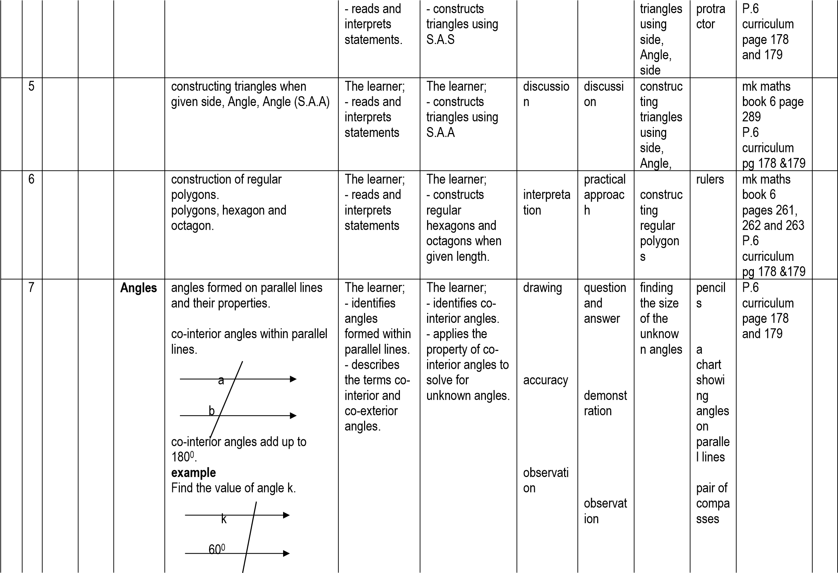

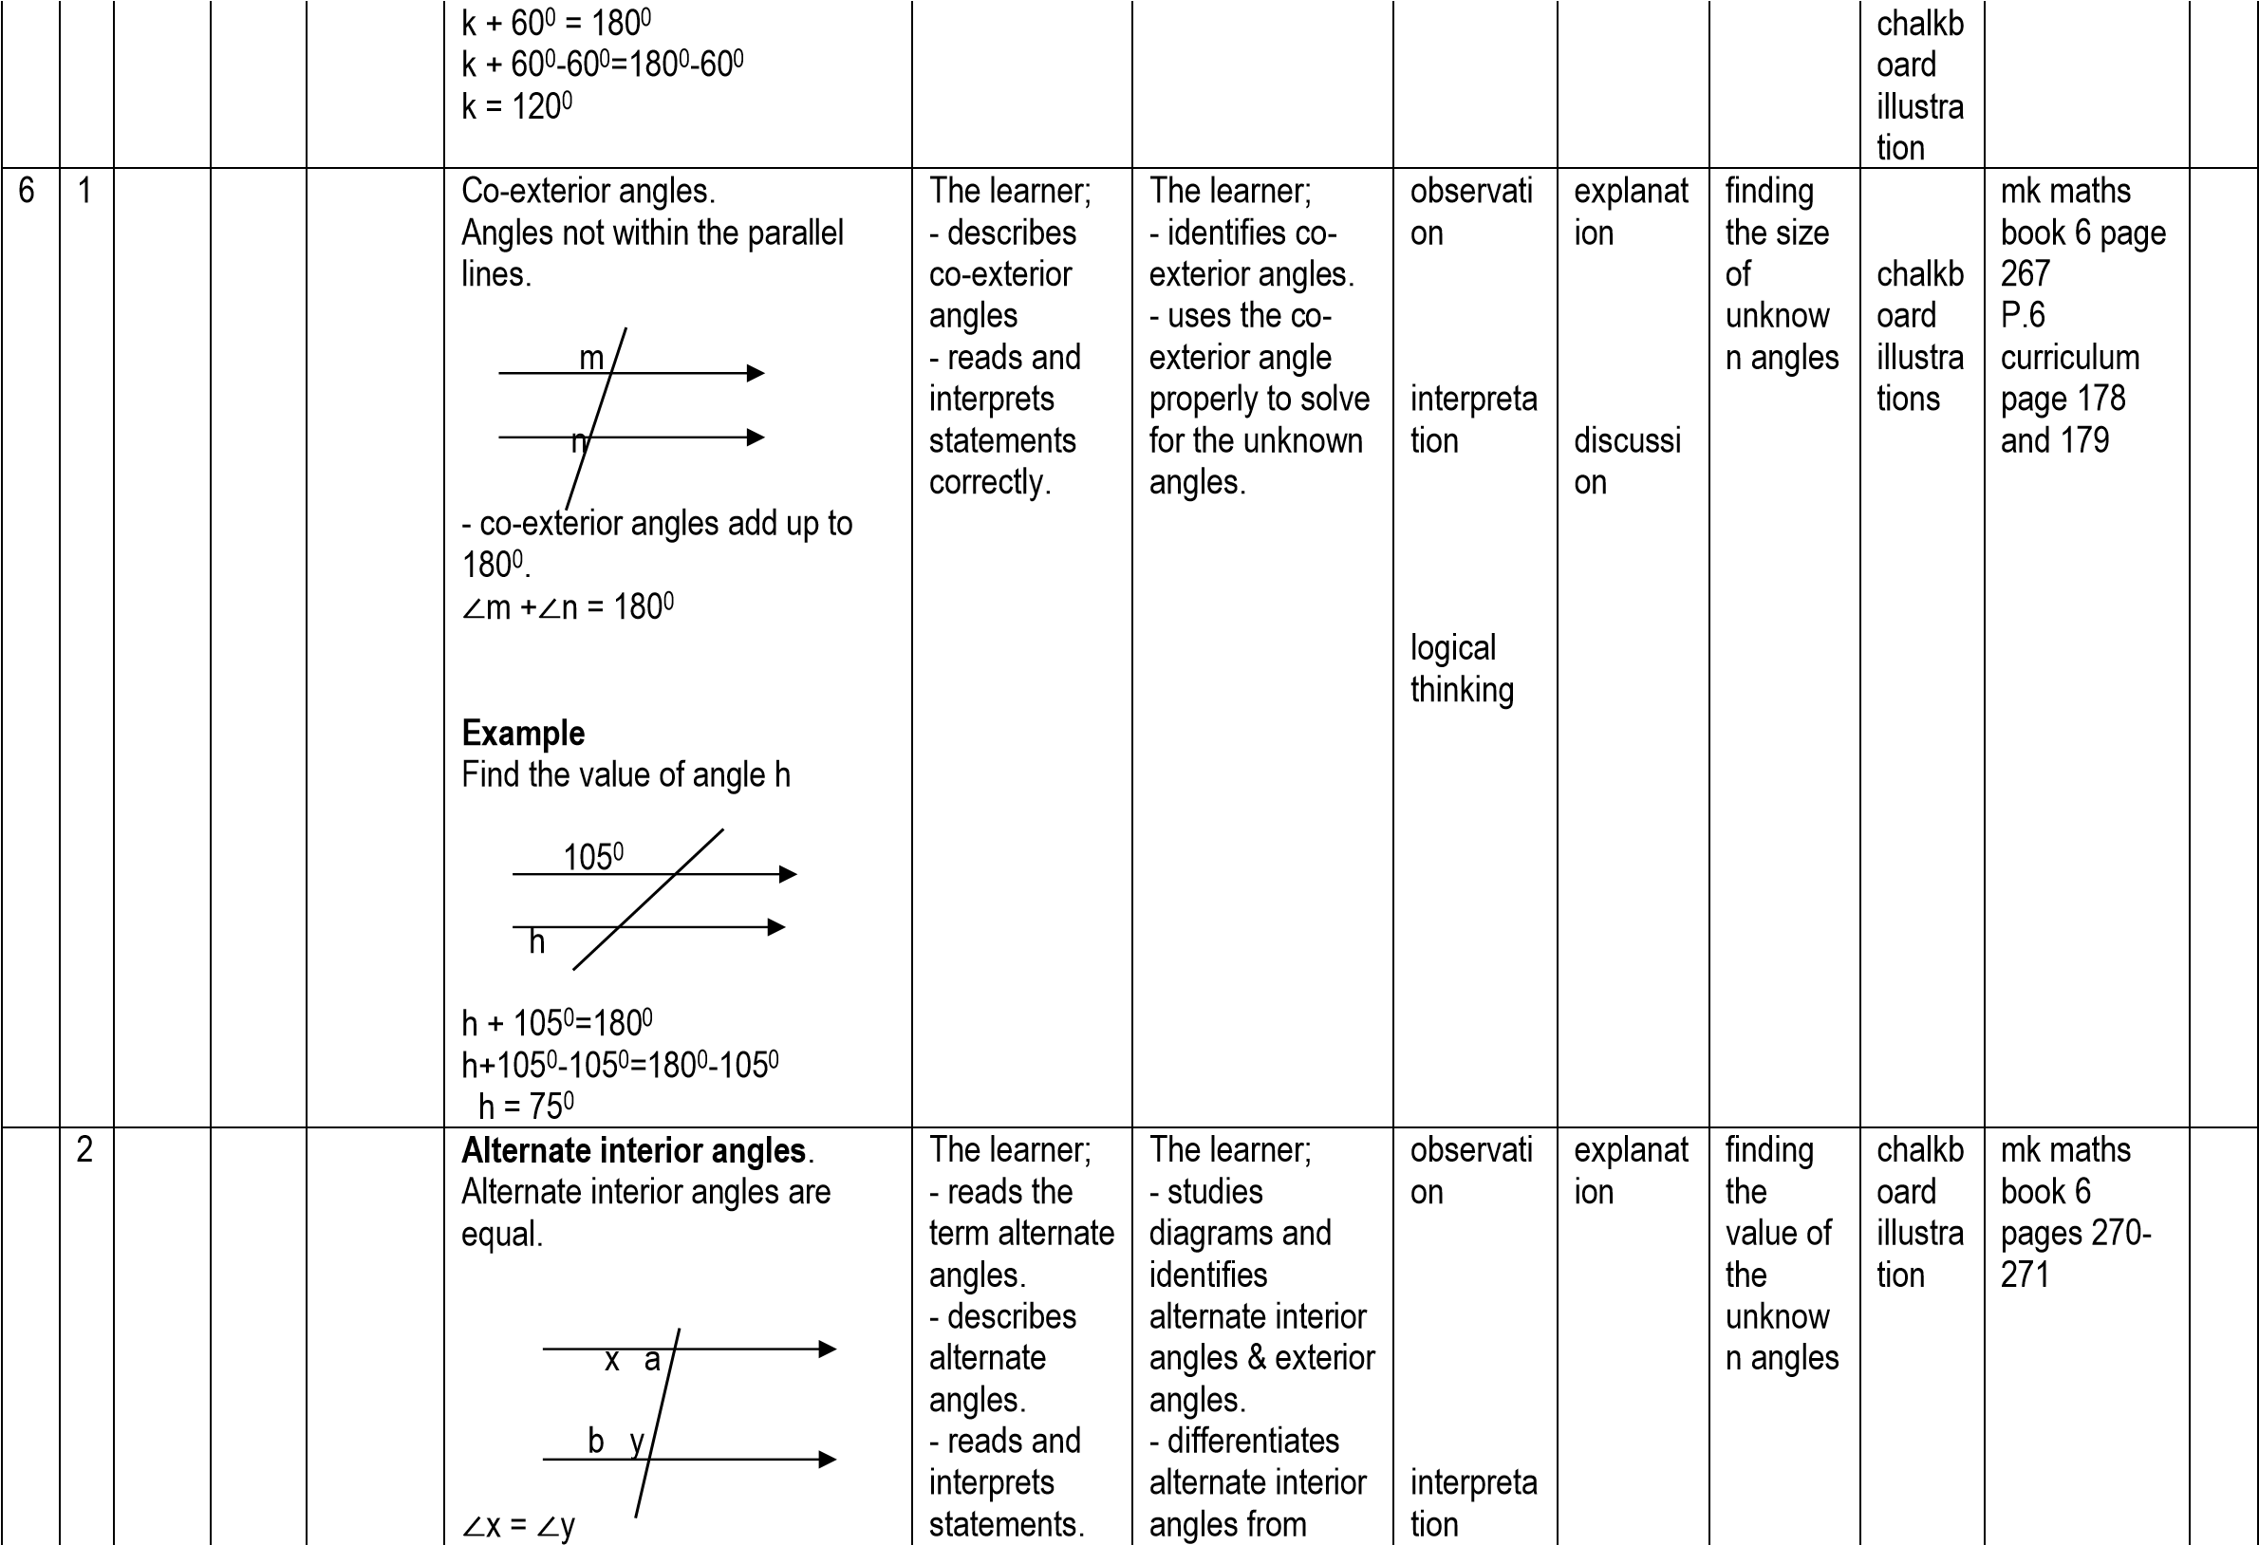

∠

a =

∠

b

**Example.**

Find angle p

p

70

0

∠

p =70

0

alt. int.

(

∠

s)

**Alternate exterior angles.**

Alternate exterior angles are

equal.

p m

n q

∠

m =

∠

n

∠

p =

∠

q

Example.

Find angle a

86

0

a

∠

a = 86

0

alternate exterior

angles.

accuracy

effective

communi

cation

problem

solving

discussi

on

demonst

ration

observat

ion

question

and

answer

mk maths

book 7 page

209

-

210

P.6

curriculum

page 178

and 179

3

**Corresponding angles.**

-

corresponding angles

are

equal.

x a

k s

y b

l

t

∠

a =

∠

b

∠

x =

∠

y

∠

k =

∠

l

∠

s =

∠

t

The learner;

-

describes

correspondin

g angles.

-

reads and

interprets

statements

correctly.

The learner;

-

identifies

corresponding

angles.

-

finds the

unknown angles

using the

property of

corresponding

angles.

observati

on

interpreta

tion

explanat

ion

discussi

on

finding

the

value of

the

unknow

n angles

chalkb

oard

illustra

tions

mk maths

book 6 page

269

-

270

mk maths

book 7 page

211

-

212

P.6

curriculum

|  |  |  |  |  |  |  |  |  |  |  |  |  |  |
| --- | --- | --- | --- | --- | --- | --- | --- | --- | --- | --- | --- | --- | --- |
|  |  |  |  |  | **Example**  Find x  2  x  x+50  0  2x = x+500 (corr s) 2x-x= x-x +500 x = 500 |  |  | demonstr  ation | demonst  ration |  |  | page 178 and 179 |  |
|  | 4 |  |  | **Applic ation**  **of angle relatio nships on paralle l lines** | relating parallel lines angles.  **Example**  Find the value of x  110  0  100  0  80  0  x  70  0  m n   1. + 1000 = 1800 m+1000-1000=1800-1000 m = 800 2. +1100 =1800 n+1100-1100=1800-1100 n=700   x+800+700=1800 x+1500=1800 x+1500-1500=1800-1500 x = 300 | The learner; - reads and interprets statements correctly. | The learner; - studies diagrams and relates parallel lines angles. - finds the unknown angels in given figures. | problem solving | observat  ion  question and answer | finding the values of the  unknow  n angles | chalkb oard  illustra tions | mk maths book 6 page 272-273  mk maths book 7 page  213 P.6 curriculum page 178 and 179 |  |
|  | 5 |  |  |  | **Types of angles**   * Acute angles * Right angle * Obtuse angle | The learner; - reads and interprets | The learner; - identifies different types of angles. | observati on | explanat  ion | writing notes about | chalkb oard  illustra tions | mk maths book 6 page 273 (old edition) |  |

|  |  |  |  |  |  |  |  |  |  |  |  |  |  |
| --- | --- | --- | --- | --- | --- | --- | --- | --- | --- | --- | --- | --- | --- |
|  |  |  |  |  | * Straight angle * Reflex angle | statements correctly. | - describes the types of angles and  differentiates them. - names given angles. |  | discussi on | types of angles. naming given angles |  | P.6 curriculum page 178 and 179 |  |
|  | 6 |  |  |  | **Complementary angles**  Angles which add up to 900.  Example  1) Find the complement of 400. Let the comp be y y + 400 = 900 y +400-400=900-400  y = 500  2) Find the value of a in the figure.  38  0  a  a +380 = 900 a+380-380=900-380 a = 520 | The learner; - describes complementa ry angles. - reads and interprets statements. | The learner; - solves problems  involving finding the complement of angles. | interpreta tion  logical thinking  problem solving  critical thinking | observat  ion  question and answer | finding comple mentary angles | chalkb oard  illustra tion | mk maths book 6 page 271-272 old  edition P.6 curriculum page 178 and 179 |  |
|  | 7 |  |  |  | **Supplementary angles.**  Angles which add up to 1800. **Examples.**   1. Which is the supplement of 320?   Let the supp be t t +320=1800 t =320-320=1800-320 t = 1480   1. Calculate the value of y in degrees. | The learner; - describes supplementar y angles. - reads and interprets statements. | The learner; - solves  problems  involving finding the supplement of given angles. | logical thinking  observati on | explanat  ion | finding  the  supplem  ents of given angles | chalkb oard  illustra tion | mk maths book 6 page  266-289 P.6 curriculum page 178 and 179 |  |

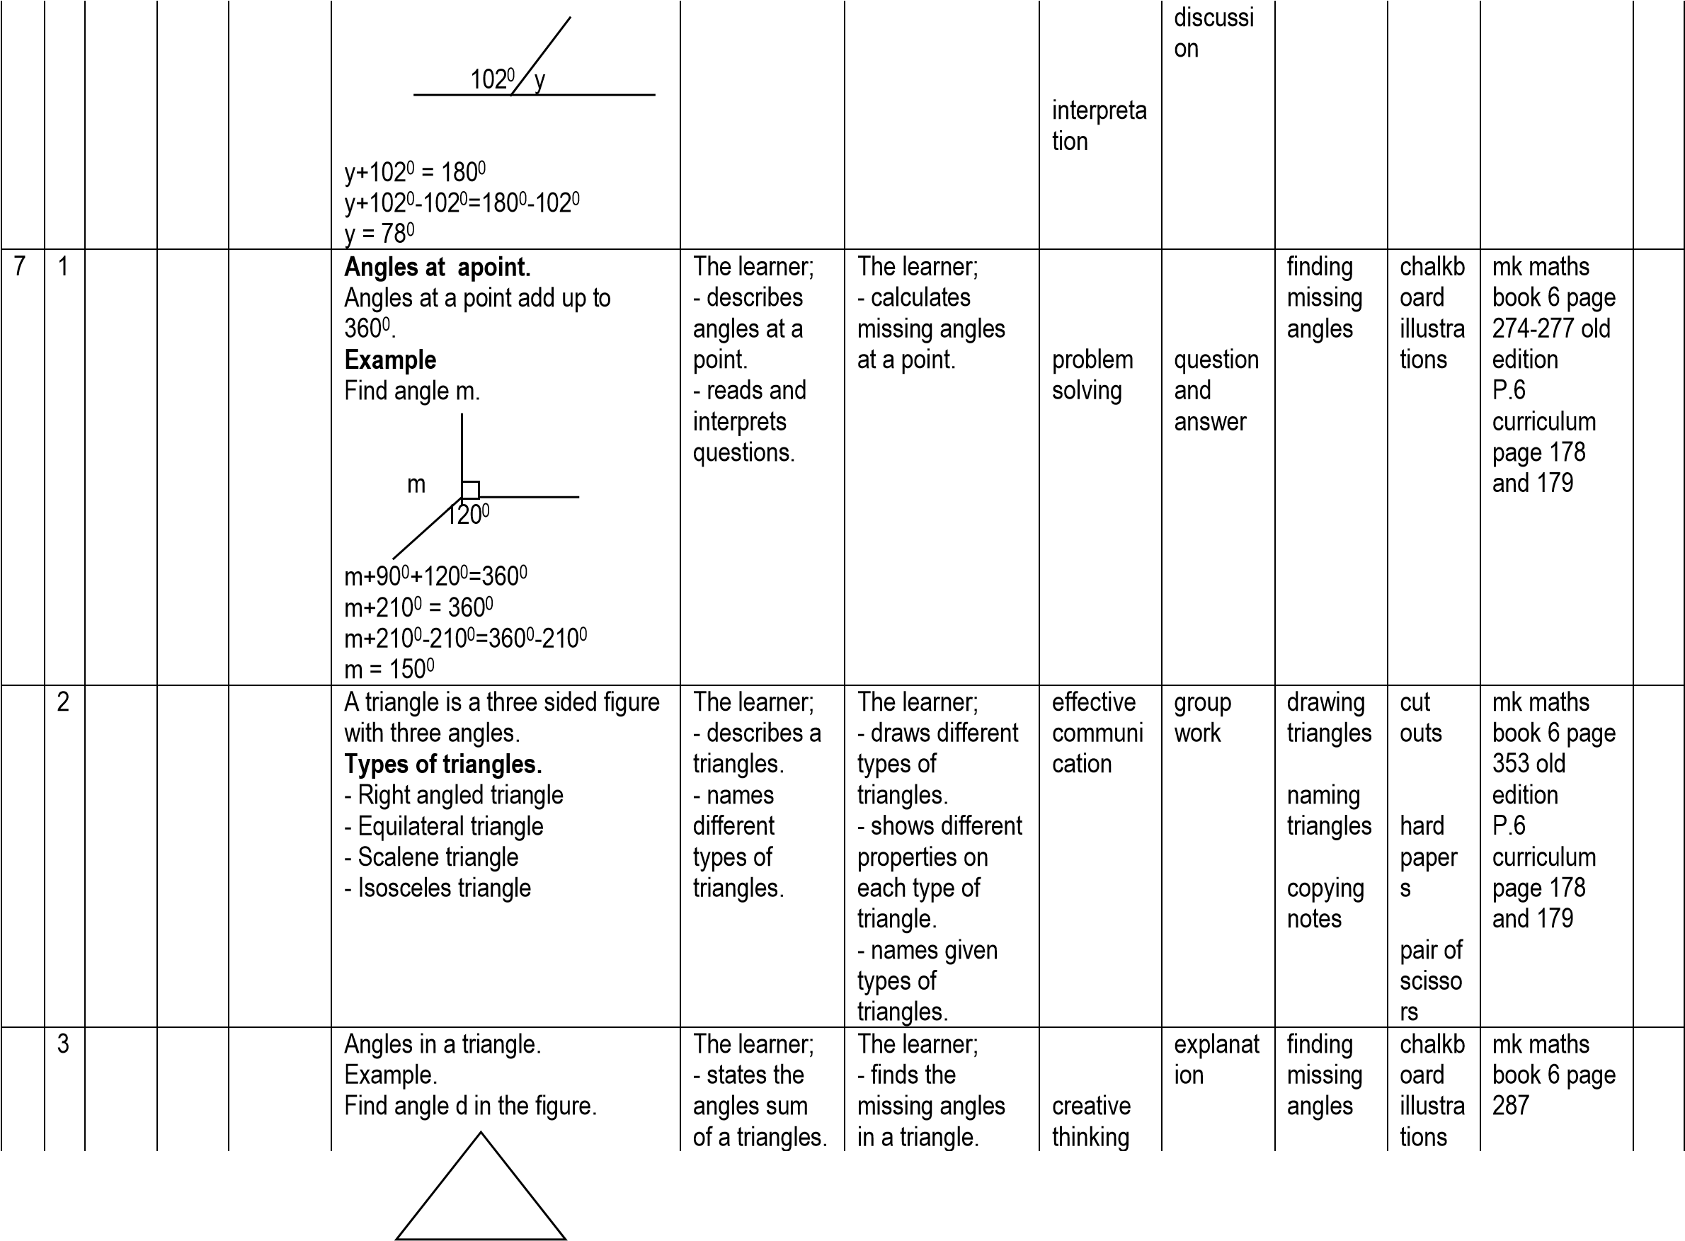

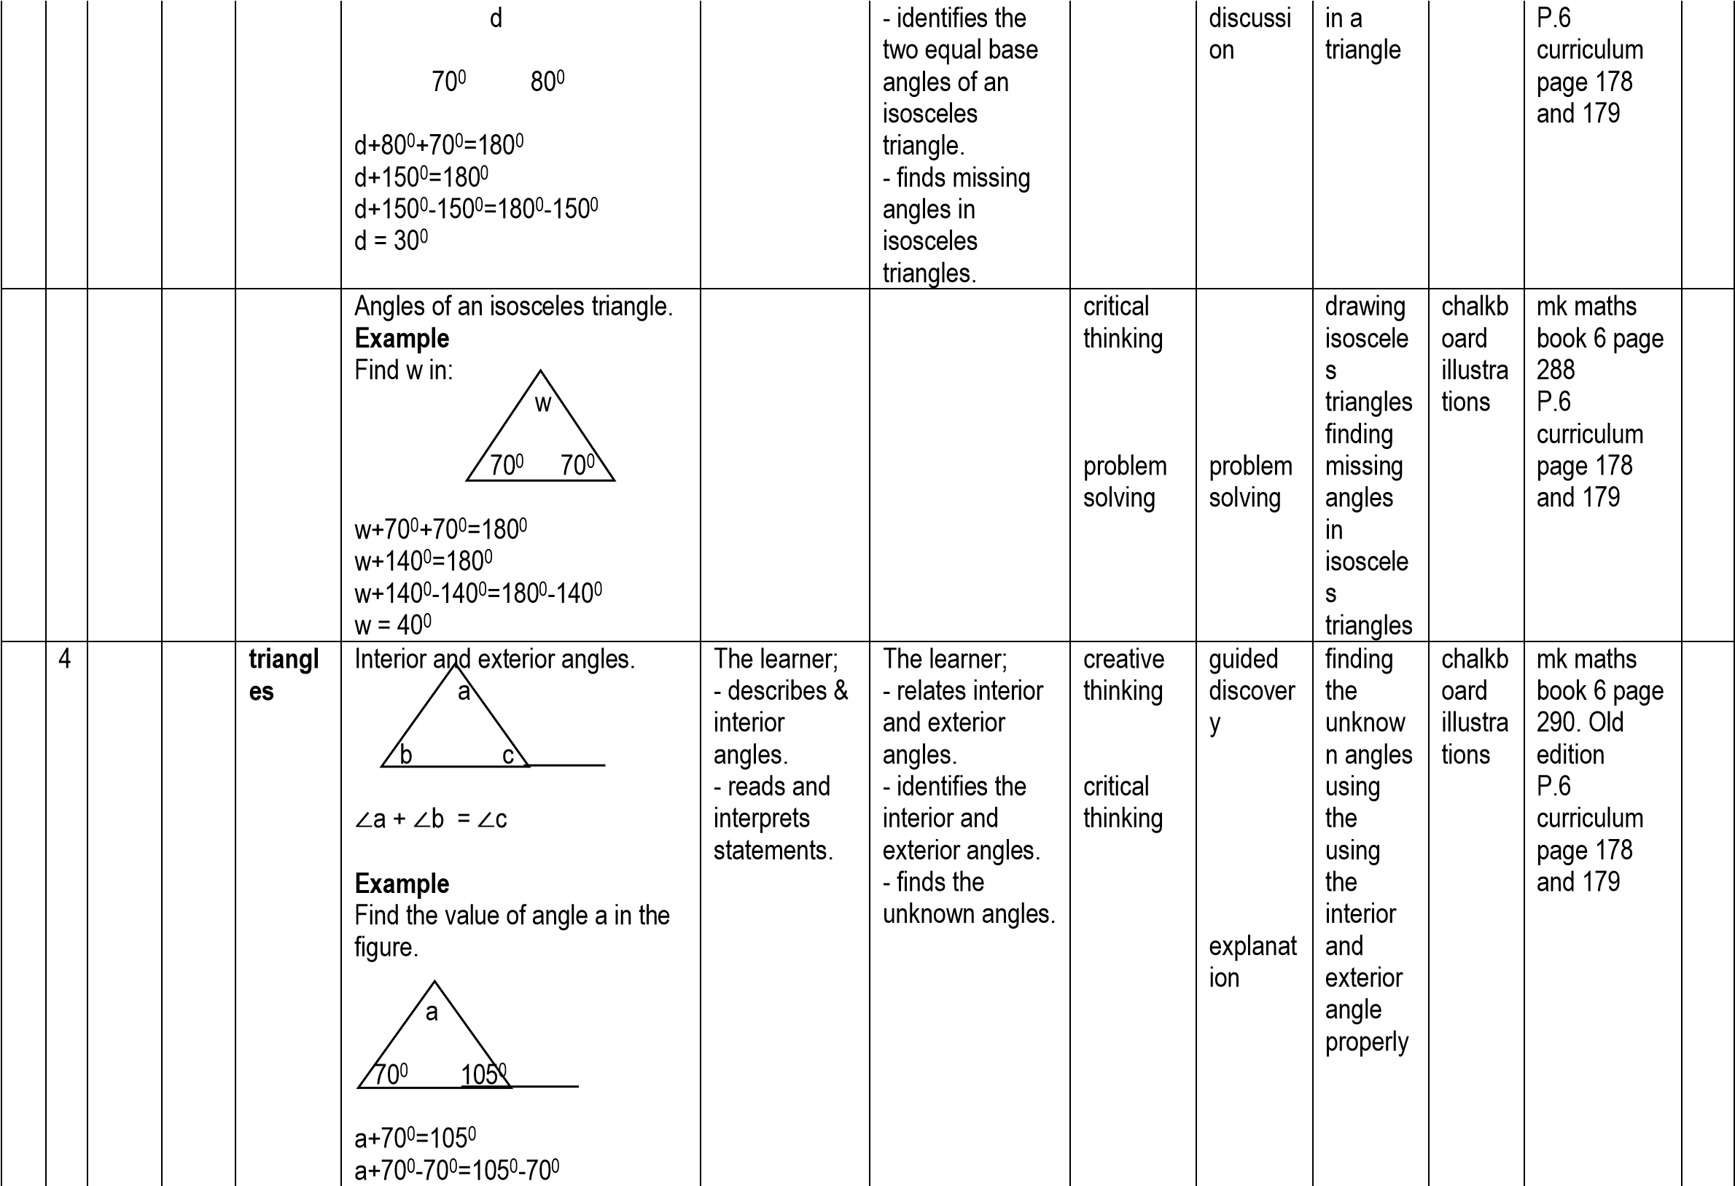

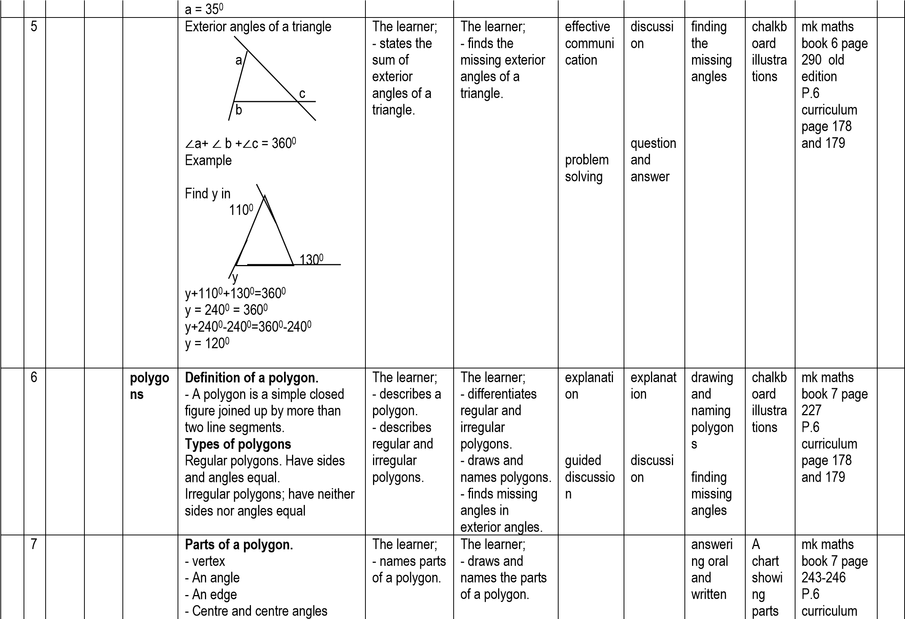

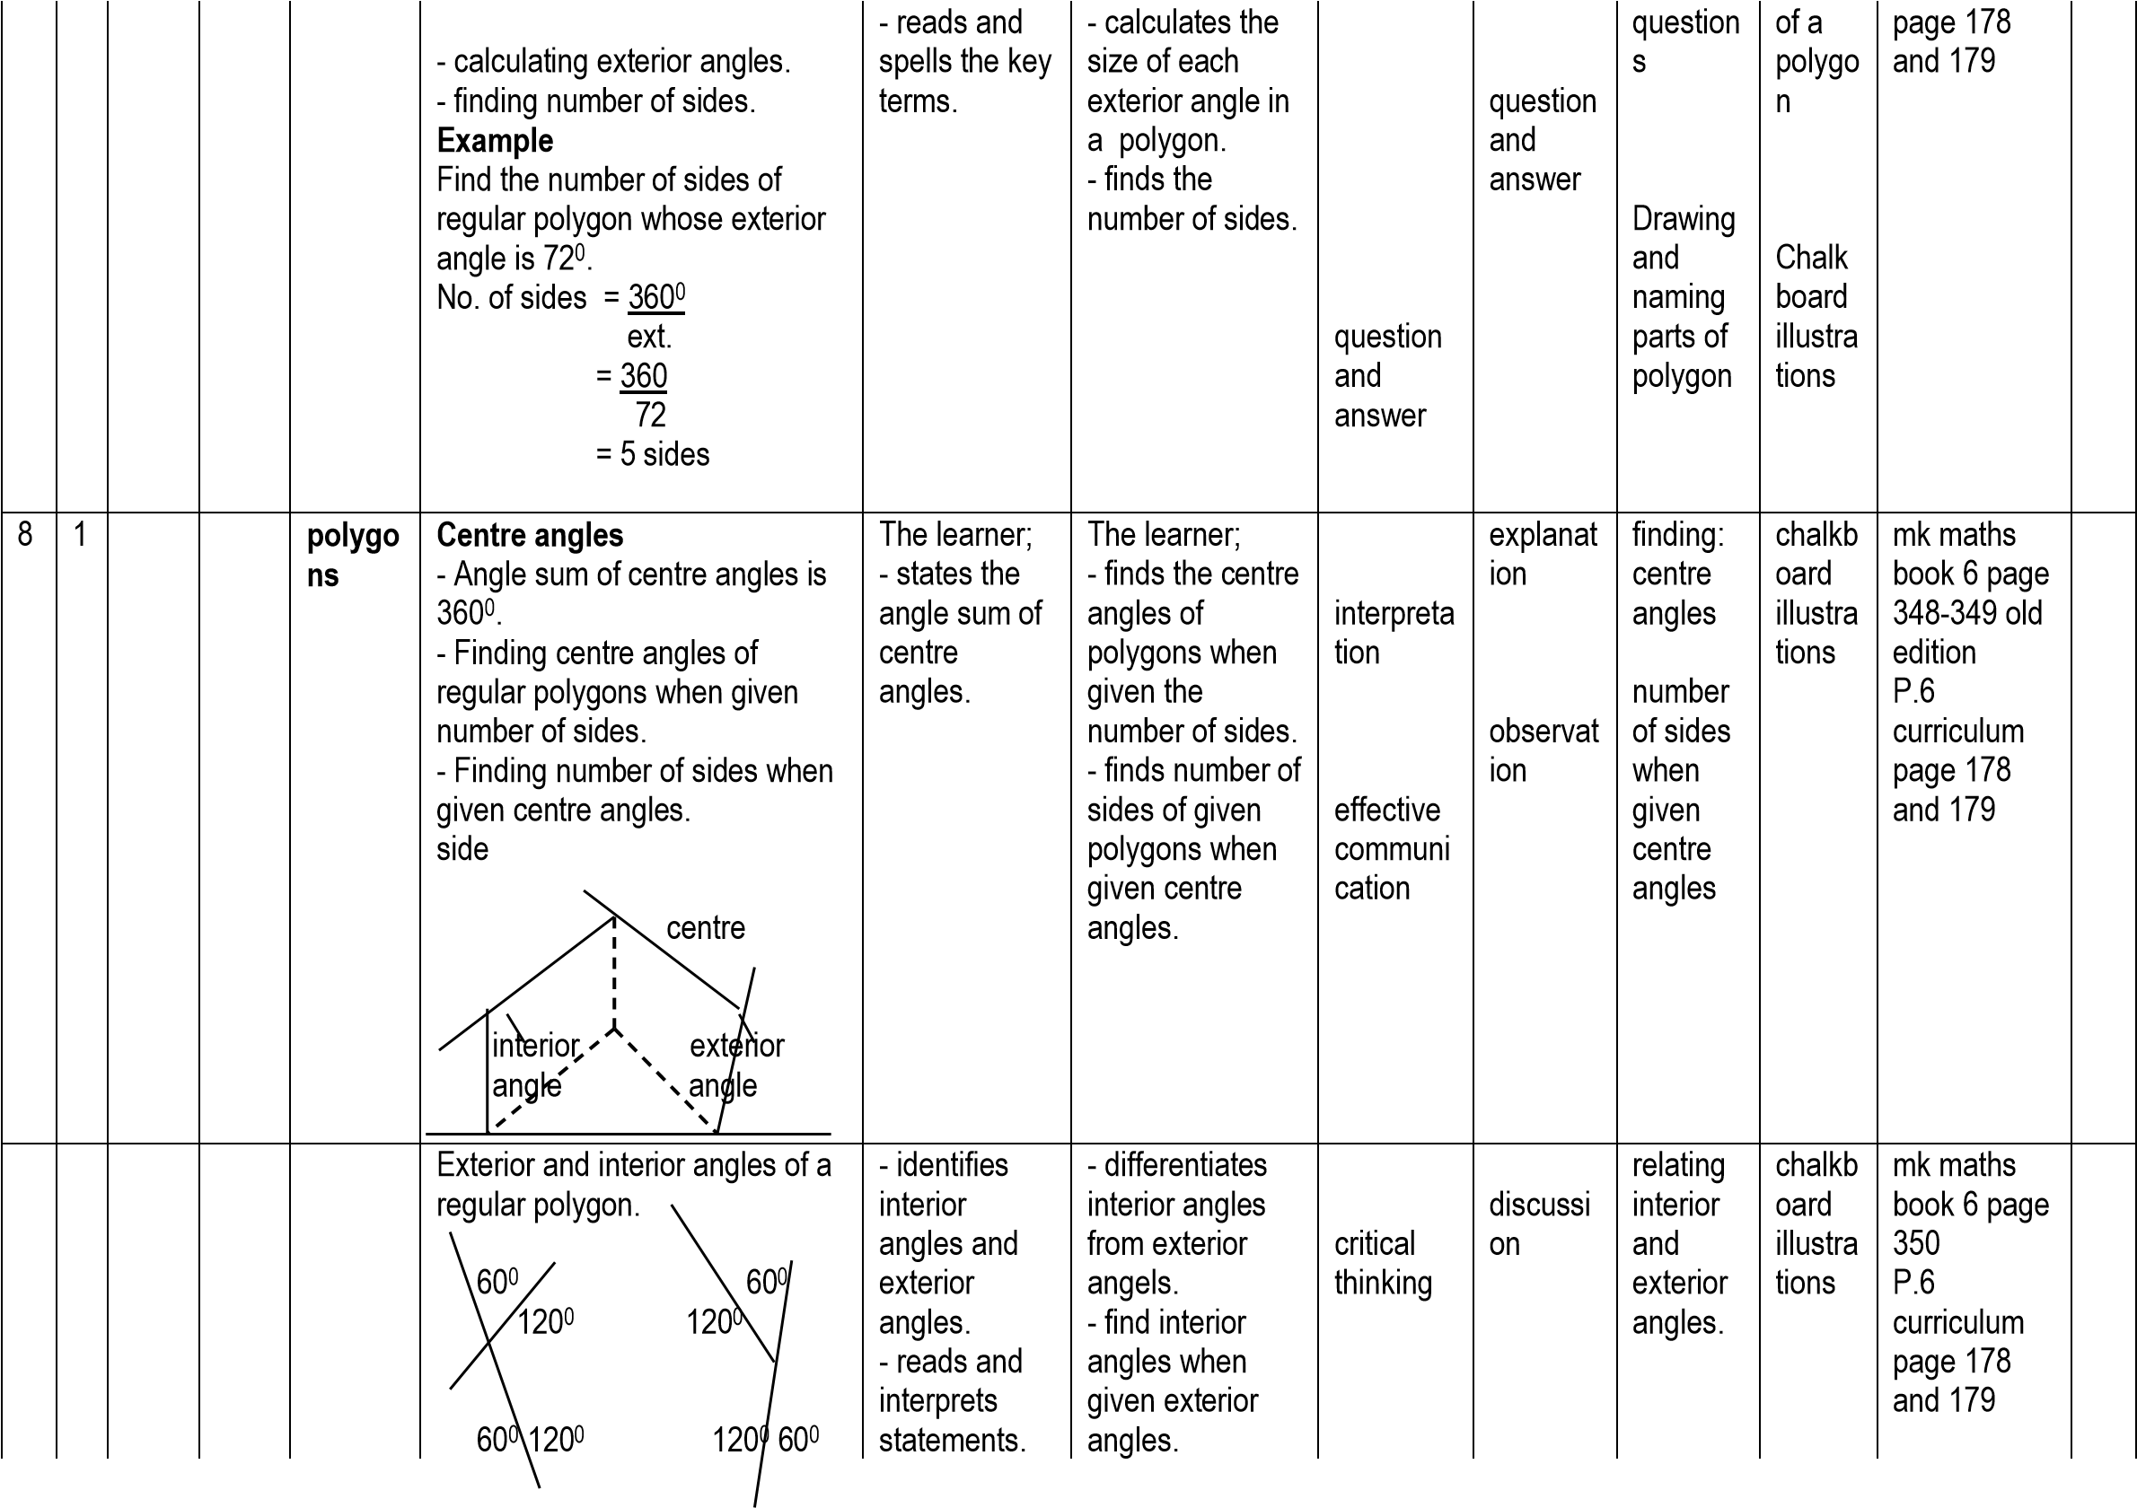

|  |  |  |  |  |  |  |  |  |  |  |  |  |  |
| --- | --- | --- | --- | --- | --- | --- | --- | --- | --- | --- | --- | --- | --- |
|  |  |  |  |  | Finding interior angles.  Example  Find the interior angle of a polygon whose exterior angle is 1080. int.  + ext. = 1800 int. + 1080 = 1800 int. + 1080-1080=1800-1080 int. = 720 |  | - finds exterior angels when given interior angles. | problem solving | question and answer | finding missing angles |  |  |  |
|  | 2 |  |  | **Polygo ns** | Sum of interior angles or interior angle sum of a polygon-using all methods. **Example**  Find the interior angle sum of a  polygon with 8 sides **Method 1**  No. of sides = 8 All ext. angles = 3600 each ext. angle = 3600  8  = 450  Int. angle = 1800-450 = 1350  Int. angle sum = 1350x8 = 10800  **Method II Method III**  900(2n-4) **OR** 1800(n-2)  900(2xn-4) 1800(8-2)  900(2x8-4) 1800(6)  900(16-4) 1800x6  900 (12) 10800  900x12  10800 | The learner; - reads and interprets statements. | The learner; - applies different methods to find the interior angle sum of given polygons. | interpreta tion  observati on  effective communi cation  logical thinking  problem solving | explanat  ion  Guided discussi on  observat ion  question & answer | finding  interior angel sum | chalkb oard  illustra tion | mk maths book 6 page  351-352 P.6 curriculum page 178 and 179 |  |

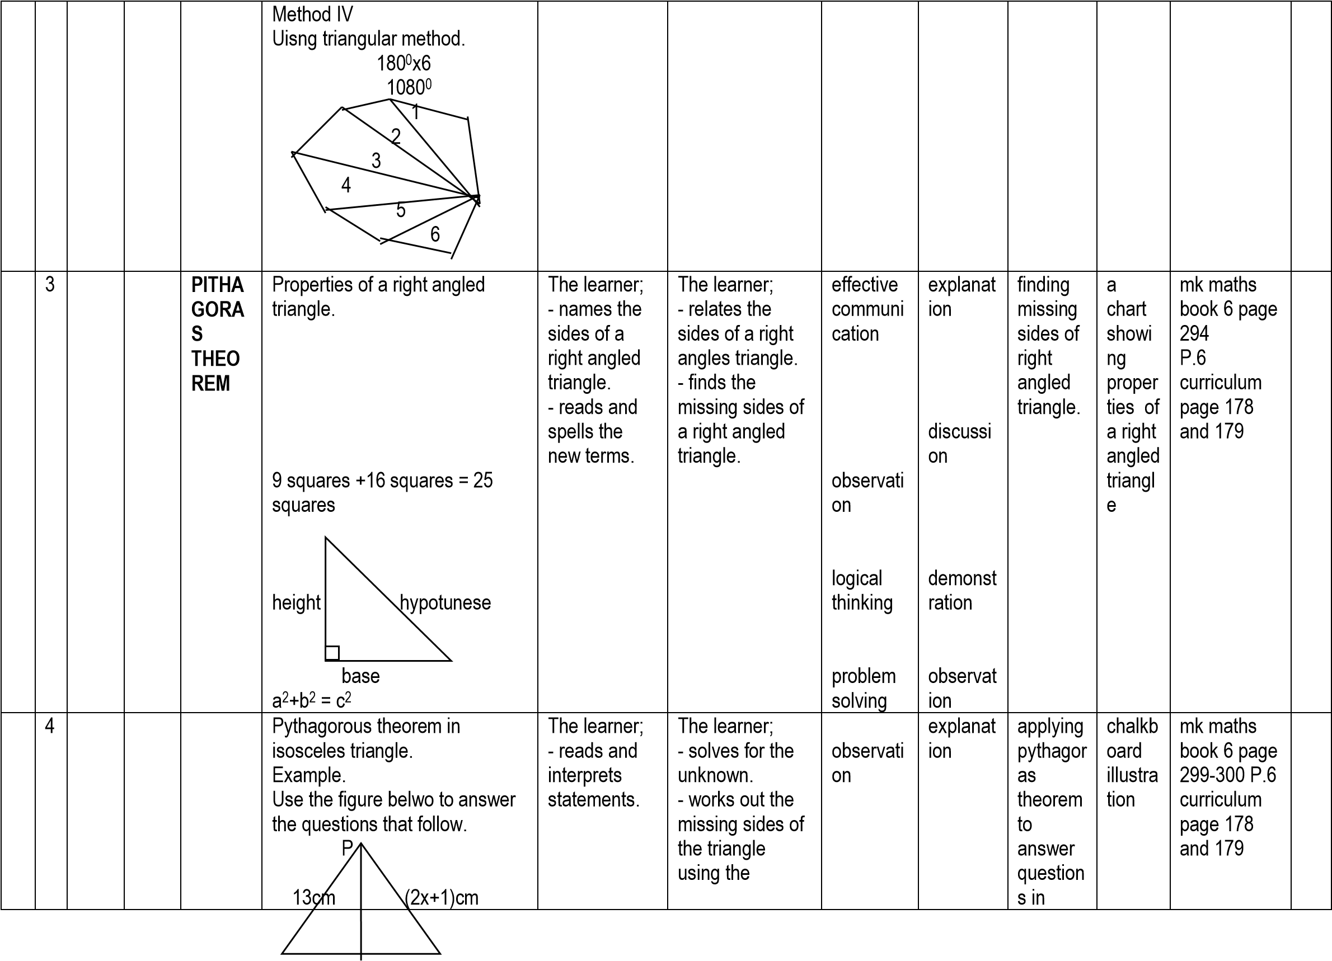

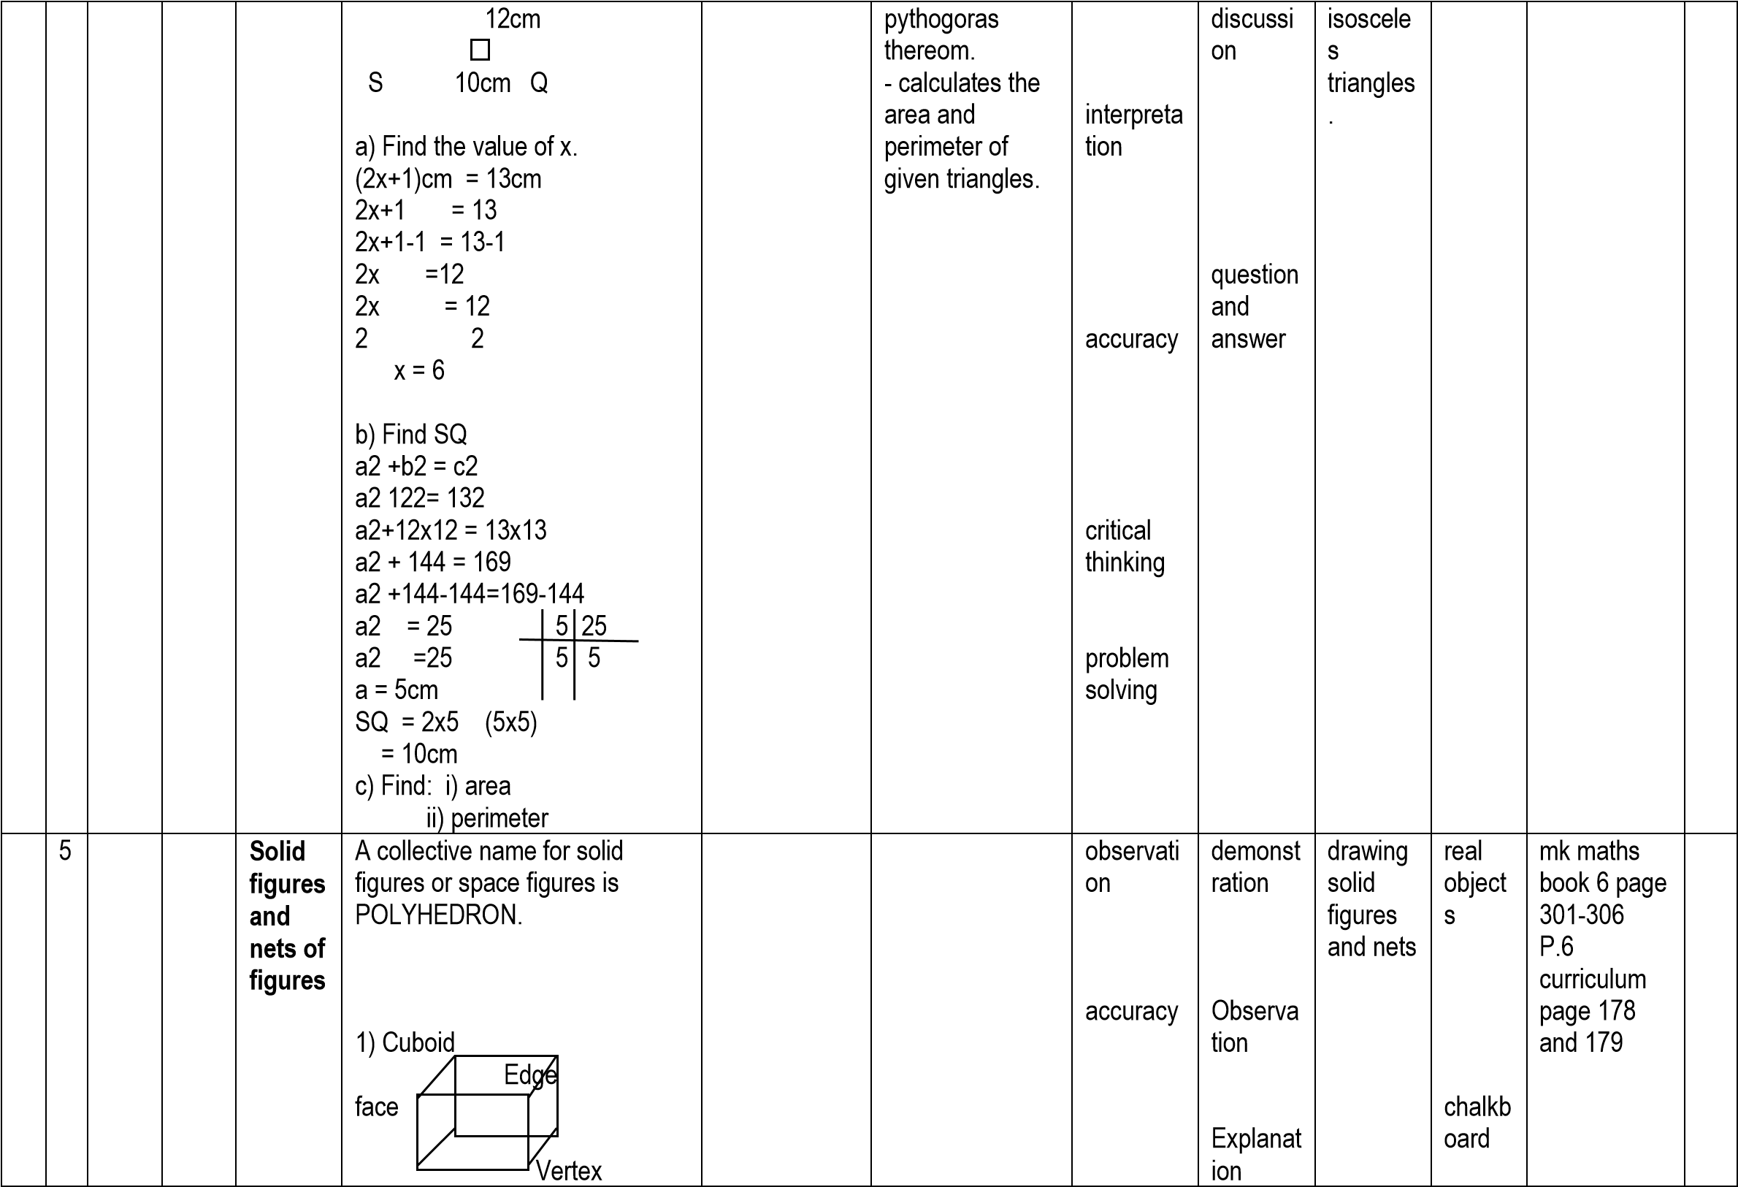

|  |  |  |  |  |  |  |  |  |  |  |  |  |  |
| --- | --- | --- | --- | --- | --- | --- | --- | --- | --- | --- | --- | --- | --- |
|  |  |  |  |  | face rectangular face  Triangular prism  edge  triangular |  |  | effective communi  cation  problem solving | Discussi on  question and answer |  | illustra tion |  |  |
|  | | | | | | | | | | | | | |
|  | 6 | **NU**  **ME**  **RA**  **CY** | **INT**  **EG**  **ERS** | **Integer s on a numbe**  **r line** | Integers on a numberline. i) Positive integers ii) Neutral integers iii) Negative integers  -4 -3 -2 -1 0 1 2 3 4 5  negative positive integer integer  neutral integer  2) Opposite/inverse of integers  (additive inverse)  - The sum of an integer and its inverse is zero (0).  Example  -2 ++2 = 0, so the opposite of -2 is +2.  Example  What is the additive inverse of +8?  Let the inverse be k | The learner; - describes integers - reads and describes the term positive, neutral & negative integers. | The learner; - plots integers on a number line.  - finds the inverse of given integers. | observati on  interpreta tion  logical thinking  effective communi  cation  problem solving | explanat  ion  discussi on  illustrati  on  question and answer | plotting and naming integers  on a number  line  finding inverse | chalkb oard  illustra tions | mk maths book 6 page  195 P.6 curriculum page 181 and 182 |  |

|  |  |  |  |  |  |  |  |  |  |  |  |  |  |
| --- | --- | --- | --- | --- | --- | --- | --- | --- | --- | --- | --- | --- | --- |
|  |  |  |  |  | k + +8 = 0 k + +8 = 0 k + 8 =0 k+8-8=0-8 k = -8  3) Find the inverse of -5, Let the inverse be a a+-5 = 0 a+-5 = 0 a -5 = 0 a – 5+5 = 0+5 a = +5 |  |  |  |  |  |  |  |  |
|  | 7 |  |  | **Repres enting integer s using arrows** | Naming arrows on number lines. Example  Which integer is represented by each arrow?  a b  -5 -4 -3 -2 -1 0 1 2 3 4 5 c  a =-4 b = 3 c = +4  Drawing number lines showing integers.  **Example**  Draw a number line and show +6.  +6  -3 -2 -1 0 1 2 3 4 5 6 | The learner;  - names  arrows on a number line - reads and interprets statements. | The learner; - writes integers on number lines. - draws number lines to show given integers. | drawing  accuracy  interpreta tion | demonst  ration  observat  ion  illustrati  on | naming arrows on given number lines.  drawing  number lines and showing integers on them. | chalkb oard  illustra tion | mk maths book 6 page  196 P.6 curriculum page 181 and 182 |  |
| 9 | 1 |  |  | **Compa**  **ring integer s** | Comparing integers using >, <  or = (symbols)  Examples  Use <, > or to complete correctly. 1) -4 - +4 | The learner; - reads and interprets statements correctly. | The learner;  - draws number  lines - plot given integers on number lines. | effective communi  cation | discussi on | compari ng given integers | chalkb oard  illustra tions | mk maths book 6 page  197 P.6 curriculum |  |

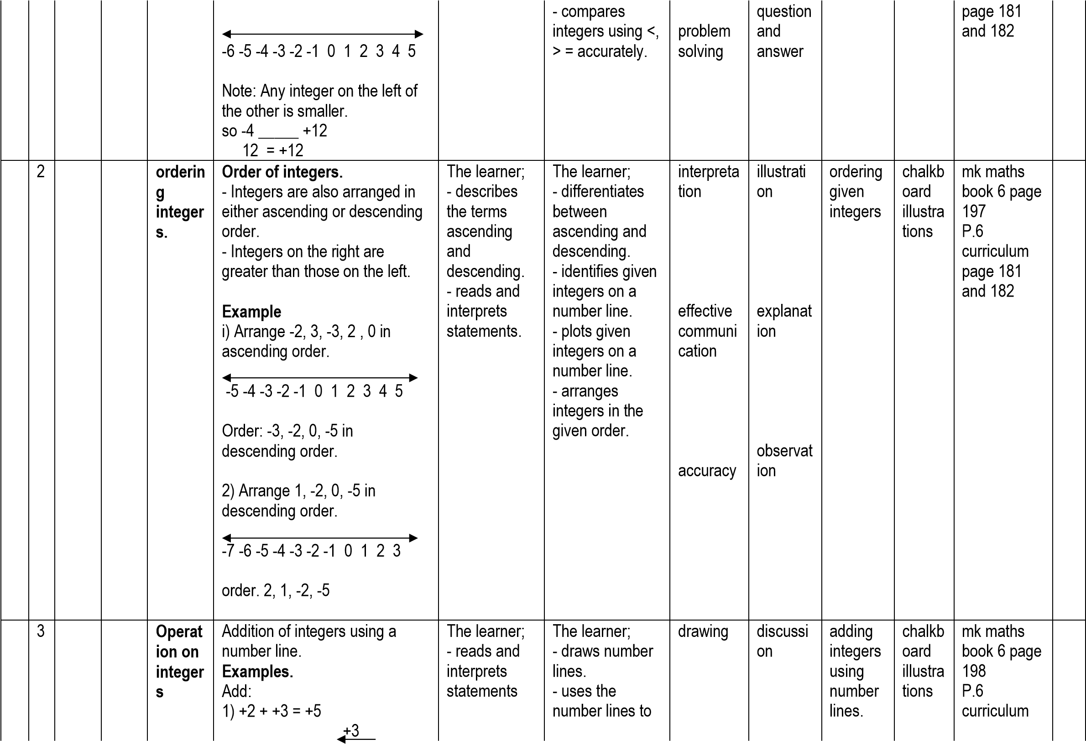

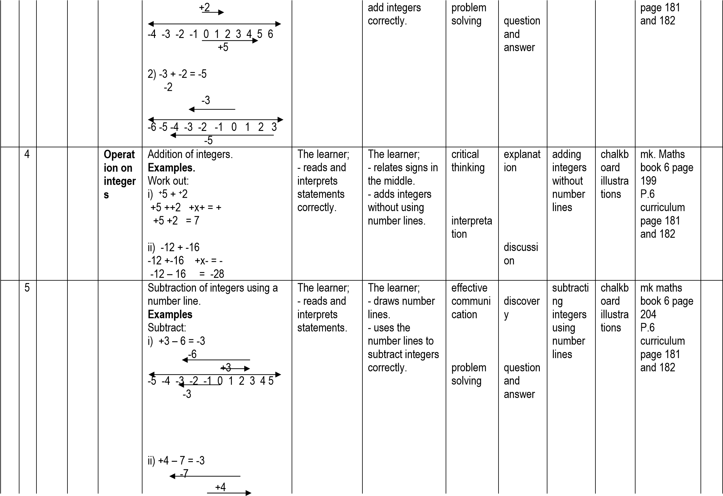

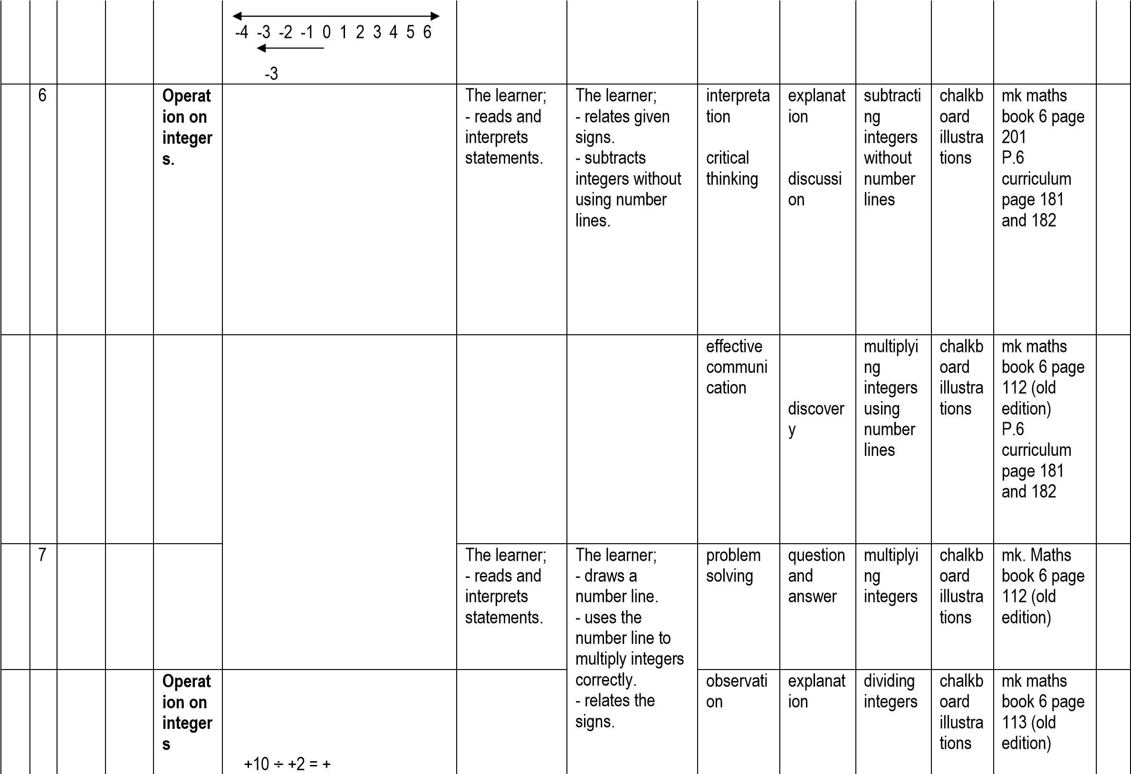**Subtraction of integers**.

**Examples**

Simplify:

i) 7 – 5 iii) -7 - +5

7 – 5 -7 -+5 – x +

=2 -7 – 5

= -12

ii) +7 -+5 iv) 4 - -2

+7-+5 –x + 4 - -2

+7-5 4+2

=2 =6

Multiplicaton integers on a number line.

**Example**

Work out: +3x+2=+6

(3 groups of 2)

+2 +2 +2

-3 -2 -1 0 1 2 3 4 5 6

+6

**Multiplication of integers.**

**Examples**Work out:

i) -6 x +3 ii) -6 x -3

-6 x+3 -6 x -3

= -18 = +18

**Division of integers**

**Examples**

Simplify:

i) +10 ÷ +2 = +÷+

|  |  |  |  |  |  |  |  |  |  |  |  |  |  |
| --- | --- | --- | --- | --- | --- | --- | --- | --- | --- | --- | --- | --- | --- |
|  |  |  |  |  | = +5  ii) -8 ÷ +2 - ÷ +  -8 ÷ +2 = -  = -4 iii) -48 ÷ -8 - ÷ -  -48 ÷ -8 = +  = +6  Emphasis on:  + ÷ + = + - ÷ - = +  + ÷ - = - - ÷ + = - |  | - multiplies without a number line. - divides integers correctly. | interpreta tion | discussi on |  |  | P.6 curriculum page 181 and 182 |  |
| 1  0 | 1 |  |  | **Inequa**  **lities** | **Sets on a number line.**  a) Interpreting sets of integers on number lines.  Example.  Write the set y shown below.  -2 -1 0 1 2 3 4 5 6 7 8  Set y ={-1, 0, +1, +2,  +3,+4,+5,+6}  b) Representing sets of integers on a number line.  Example.  Represent X={-2, -1, -1, 0, 1, 2, 3} on a number line.  -4 -3 -2 -1 0 1 2 3 4 | The learner; - interprets sets of integers on number line. | The learner; - represents sets of integers on number lines. | effective communi  cation | discover y  question and answer | interpreti ng and represe nting sets of integers on number lines. | chalkb oard  illustra tions | mk maths book 6 page 114 (old  edition)  P.6 curriculum page 181 and 182 |  |
|  | 2 |  |  |  | **Finding solution sets for theinequalities.**  **Examples.**  Give the solution set for: i) x if x > 2  -3 -2 -1 0 1 2 3 4 5 6 7 x = {3, 4, 5, 6, …..} ii) p if p  2 | The learner; - reads and interprets statements correctly. | The learner;   * draws number lines. * finds the solution set. | observati on  interpreta tion | explanat  ion  discussi on | finding solution s sets. | chalkb oard  illustra tions | mk maths book 6 page 115 old edition.  Mk book 6 page 399 New edition |  |

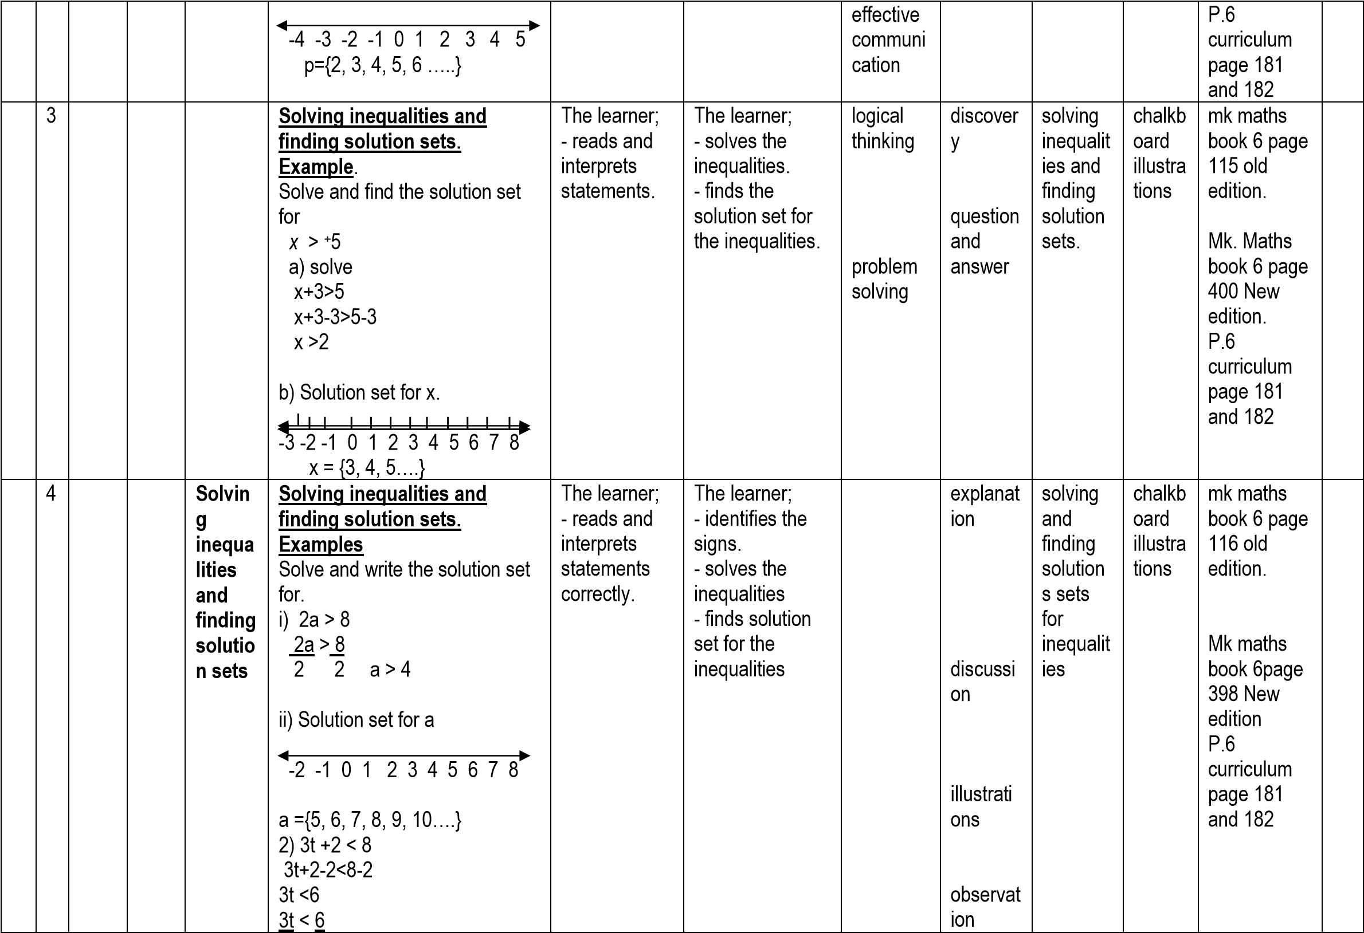

|  |  |  |  |  |  |  |  |  |  |  |  |  |  |
| --- | --- | --- | --- | --- | --- | --- | --- | --- | --- | --- | --- | --- | --- |
|  |  |  |  |  | 3 3 t = 2 solution set for t  -5 -4 -3 -2 -1 0 1 2 3 4 t= {1, 0, -1, -2, -3, ….}  3) -10 <2x <4  -10<2x<4  2 2 2 -5 < x < 2 |  |  |  | question and answer |  |  |  |  |
| ***ELO: The learner forms and solves algebraic problems.*** | | | | | | | | | | | | | |
|  | 5 | **AL**  **GE**  **BR**  **A** | **AL**  **GE**  **BR**  **A** | **Algebr aic phrase** | **Writing Algebraic phrases**.  **Examples**  i) Add b to a  b to a = a + b  ii) Multiply x and y X x y = xy  Expressing phrases i) 2 more than p = p + 2   1. 5 years younger than x.= x – 5 2. square y = y x y   = y2 | The learner; - reads and interprets statements. | The learner; - identifies the operations to be used.   * writes algebraic expressions/phr ases. * identifies like terms. * collects and simplifies like terms. | critical thinking  problem solving | explanat  ion  discussi on | forming Algebrai c expressi ons | chalkb oard  illustra tions | mk maths book 6 page  377 P.6 curriculum page 184 and 185 |  |
|  |  |  |  | **Collect ing and simplif ying like terms**. | **Collecting like terms.**  **Examples**   1. x+y+2x+4yx+2x+y+4y 3x+5y 2. 4p+9r – p- 6r   4p-p + 9r-6r  3p+3r |  |  | creative thinking  effective communi  cation | question and answer | collectin g and simplifyi ng like terms. | chalkb oard  illustra tions | mk maths book 6 page  378 P.6 curriculum page 184 and 185 |  |

|  |  |  |  |  |  |  |  |  |  |  |  |  |  |
| --- | --- | --- | --- | --- | --- | --- | --- | --- | --- | --- | --- | --- | --- |
|  |  |  |  |  | iii) 4n+3t-m+5n+6m-4t  4n+5n+3t-4t+6m-m 9n-t+5m |  |  |  |  |  |  |  |  |
|  | 6 |  |  | **Remov**  **ing bracke ts.** | **Removing brackets andsimplifying.Example.**   1. 2 (2m+3)   2x2m + 3x2 4m +6   1. 4 (p+1) – 5(p-3)   4xp+1x4-5xp-3x-5  4p+4-5p+15  4p-5p+4+15  -p +19  = 19-p | The learner; - reads and interprets statements. | The learner;  - relates signs - removes brackets and simplifies correctly. | effective communi  cation  critical thinking | explanat  ion  discussi on | written activity involving removin g brackets  and  simplifyi ng equation  s. | chalkb oard  illustra tions | mk. Maths book 6 page 380 and page 382 P.6 curriculum page 184 and 185 |  |
|  | 7 |  |  |  | **Removing brackets involvingfractions.**  **Examples**  Remove the brackets and simplify:  i) ½ (8a + 4b) ½ x 8a +4b x ½  1x4a + 2b x 1  4a + 2b ii) ½ (2x+2y) – ¼ (12x16y) ½ x 2x+2yx ¼ - ¼ x 12x-16yx –  ¼  1xx+yx1-1x3x-4yx-1 x+y – 3x+4y x-3x+y+4y -2x +5y  5y – 2x | The learner; - reads and interprets statements. | The learner;   * removes brackets - simplifies fractions using the correct factors. * collects the like terms. | problem solving  logical thinking | observat  ion  question and answer | simplifyi ng brackets involving fractions | chalkb oard  illustra tions | mk maths book 6 page  381 P.6 curriculum page 184 and 185 |  |
| 1  1 | 1 |  |  | **Subtra ction** | **Definition of subtraction.**  **To substitute is to replace.**  **Examples.** | The learner; | The learner; | effective communi  cation | explanat ion | answeri  ng oral and | chalkb oard | mk maths book 6 page 376 |  |

|  |  |  |  |  |  |  |  |  |  |  |  |  |  |
| --- | --- | --- | --- | --- | --- | --- | --- | --- | --- | --- | --- | --- | --- |
|  |  |  |  |  | Given that a=2 and b=6, evaluately , find the value of work out etc: i) b + a  6 + 2 = 8  ii) 2a + 3b  2xa +3 x b  2x2 + 3x6  4 + 18 = 22 | - describes the term substitution | - substitutes letters with figures/numbers. | interpreta tion | discussi on | written question s | illustra tions | P.6 curriculum page 184 and 185 |  |
|  | 2 |  |  | **solvin g equati ons** | **Solving simple equationsunvolving addition andsubtraction.**  **Examples**  Solve these equations i) x + 4 = 12  x+4-4 = 12-4 x = 8  ii) b – 3 =8  b -3+3=8+3 b = 11 | The learner; - reads and interprets statements | The learner; - identifies the sign in an equation - solves equations correctly.  - forms equations and solves them thereafter. | logical thinking  problem solving | guided discover y  question and answer | solving equation  in written activity | chalkb oard  illustra tions | mk maths book 6 page 385 and 386  P.6 curriculum page 184 and 185 |  |
|  |  |  |  |  | **Forming and solvingequations.**  **Examples**  i) Amanda had some pineapples, she bought 6 more pineapples and got 11 pineapples altogether. H ow many pineapples had she before?  Let the pineapples be t. t + 6 = 11 t +6-6 = 11-6 t = 5 |  |  | interpreta tion effective communi  cation | explanat ion  guided discussi on | forming and solving equation | chalkb oard  illustra tions | mk maths book 6 page  85 and 386 P.6 curriculum page 184 and 185 |  |

|  |  |  |  |  |  |  |  |  |  |  |  |  |  |
| --- | --- | --- | --- | --- | --- | --- | --- | --- | --- | --- | --- | --- | --- |
|  |  |  |  |  | ii) Salama had some books in her bag. 4 of them were stolen and she remained with 16 books. How many books did she have at first?  Let the number of books be y. y – 4 = 16 y – 4+4 = 16 +4  y = 20 |  |  | logical thinking |  |  |  |  |  |
|  | 3 |  |  |  | **Solving equations involvingdivision.**  **Examples**. Solve:  i) 2y = 8  2y = 8  2 2 y = 4  ii) m +4m =20  5m = 20  5m = 20  5 5 m = 4 | The learner; - reads and interpret statements. | The learner; - finds the unknown by dividing. - collects like terms   * identifies the signs used. * removes brackets. - solves equations correctly. | problem solving | question and answer | solving for the  unknow  n | chalkb oard  illustra tions | mk maths book 6 page  387 P.6 curriculum page 184 and 185 |  |
|  |  |  |  | Solving equatio ns | **Solving equations**  **Examples**  Solve these equations i) 2x -3 =9  2x-3+3 = 9+3  2x = 12  2x = 12  2 2 x = 6  ii) 3(m+1) = 6  3xm+1x3 = 6  3m + 3 = 6  3m+3-3 = 6 – 3  3m = 3  3m = 3 |  |  | effective communi cation logical thinking | explanat  ion  discussi on | solving equation | chalkb oard  illustra tions | mk maths book 6 page  383 P.6 curriculum page 184 and 185 |  |

|  |  |  |  |  |  |  |  |  |  |  |  |  |  |
| --- | --- | --- | --- | --- | --- | --- | --- | --- | --- | --- | --- | --- | --- |
|  |  |  |  |  | 3 3 m = 1 |  |  |  |  |  |  |  |  |
|  | 4 |  |  |  | **Solving equations with theunknown on both sides**. Example Solve:  4h – 3 = h + 6  4h – 3+3 = h +6+3  4h = h+9  4h-h = h-h+9  3h = 9  3h = 9  3 3 h = 3 | The learner; - reads and interprets statements correctly. | The learner; - identifies the like terms. - solves given equations correctly.  - removes brackets. - relates signs - collects like terms and solves equations. | problem solving  critical thinking | guided discover y  question and answer | solving equation | chalkb oard  illustra tions | mk maths book 6 page  393 P.6 curriculum page 184 and 185 |  |
|  |  |  |  | Solving equatio ns | Solving equations with unknown  on both sides involving brackets.  Example.  Solve:  3 (y-2) = 2(y-1)  3xy – 2x3 = 2xy – 1x2  3y – 6 = 2y – 2  3y-6+6 = 2y-2+6  3y = 2y+4  3y-2y = 2y-2y+4  y = 4 |  |  | logical thinking  interpreta tion | explanat  ion  discussi on | solving equation | chalkb oard  illustra tions | mk maths book 6 page  292 P.6 curriculum page 184 and 185 |  |
|  | 5 |  |  |  | **Solving fractional equations.**  **Examples**  Solve:  i) a = 12  8  a = 12  8 1  8xa = 12x8  8 a = 96  ii) ¼ d + 3 = 15 | The learner; - reads and interprets statements. | The learner; - changes the whole number to a fractions.  - finds the LCM of the denominators. - forms equations and solves thereafter. | effective communi  cation  problem solving | guided discover y  question and answer |  |  | mk maths book 6 page  389 P.6 curriculum page 184 and 185 |  |

|  |  |  |  |  |  |  |  |  |  |  |  |  |  |
| --- | --- | --- | --- | --- | --- | --- | --- | --- | --- | --- | --- | --- | --- |
|  |  |  |  |  | ¼ d +3-3 = 15-3  ¼ d = 12  ¼ d = 12  1  4 x ¼ d = 12x4 d = 48 |  |  |  |  |  |  |  |  |
|  |  |  |  | Solving equatio ns | **Forming and solvingfractional equationa fromword problems.**  **Example**  i) Find the number of oranges that can be divided among 5 boys so that each boy gets 6 oranges.  Let the number of oranges be a a = 6 a = 6  5 5 1  5xa = 6x5  5 a = 30 |  |  | effective communi  cation  interpreta tion | explanat  ion  discussi on | reading  stateme nts  forming and solving equation | chalkb oard  illustra tions | mk maths book 6 page  389 P.6 curriculum page 184 and 185 |  |
|  |  |  |  |  | **Solving equations**  **Example**  Solve:  i) 5(t+1)-3(t-1) =14 5xt+1x5-3xt-1x-3 = 14  5t+5 – 3t +3 = 14  5t – 3t + 5+3 = 14  2t + 8 = 14  2t+8-8 = 14-8  2t = 6  2t = 6  2 2 t = 3 |  |  | logical thinking  problem solving | guided discover y  question and answer | solving equation | chalkb oard  illustra tions | mk maths book 6 page  292 P.6 curriculum page 184 and 185 |  |
|  | 6 |  |  | **Solvin g equati ons** | **Forming and solving**  **equations Examples** | The learner; - reads and interprets statements. | The learner; - forms and solves equations correctly. | interpreta tion | explanat  ion | Forming and solving equation | chalkb oard  illustra tions | mk maths book 6 page 388 and 390 |  |

|  |  |  |  |  |  |  |  |  |  |  |  |  |  |
| --- | --- | --- | --- | --- | --- | --- | --- | --- | --- | --- | --- | --- | --- |
|  |  |  |  |  | i) Anna is twice as old as Annet. Their total age is 18 years. How old is each?  **Annet Anna Total** y 2xy 18  y +2y = 18 3y = 18  3y = 18  3 3 y = 6  Annet is y = 6yrs  Anna is 2y = 2xy  = 2x6 = 12yrs  ii) A boy is 2 years older than his sister. Their total age is 20 years. How old is the sister? Sister Boy Total m m+2 20  m+m+2 = 20  2m +2 = 20  2m+2-2 = 20-2  2m = 18  2m = 18  2 2  m = 9  The sister is m = 9years. |  |  | effective communi  cation  logical thinking  problem solving | discussi on  guided discover y  question and answer |  |  | P.6 curriculum page 184 and 185 |  |
|  | 7 |  |  | **Indices** | **Products of powers with the same base. Example**  Simplify:  i) m2xm2 = mxmxmxmxm  = m5**OR:**  m2 x m3 = m2+3 | The learner; - describes the term indices - reads and interprets statements. | The learner; - applies the index rule to find products of powers with the same base. - divides powers of the same | interpreta tion  logical thinking | explanat  ion | multiplyi ng  powers  with the same base | chalkb oard  illustra tions | mk maths book 6 page 383  P.6 curriculum |  |

|  |  |  |  |  |  |  |  |  |  |  |  |  |  |
| --- | --- | --- | --- | --- | --- | --- | --- | --- | --- | --- | --- | --- | --- |
|  |  |  |  |  | = m5  ii) 4y2 x 3y4  = 4xyxyx3xyxyxyxy  = 4x3xyxyxyxyxyxy  = 12y6  **OR:**  4y2x3y4=4x3xy2+4  = 12xy6  = 12y6 |  | base using long division and index rule. |  | guided discussi on |  |  | page 184 and 185 |  |
|  | 7 |  |  |  | **Dividing powers of the same base.**  **Examples**.  Simplify:   1. p7 ÷ p5 = pxpxpxpxpxpxp pxpxpxpxp = pxp = p2 OR:   p7 ÷ p5 = p7-5 = p2   1. 12t4 ÷ 3t2   12xtxtxtxt  3xtxt  = 4xtxt = 4t2 |  |  | effective communi  cation  Problem solving | Questio n and answer | Dividing powers  with the same base. | chalkb oard  illustra tions | mk maths book 6 page  384  P.6 curriculum page 184 and 185 |  |